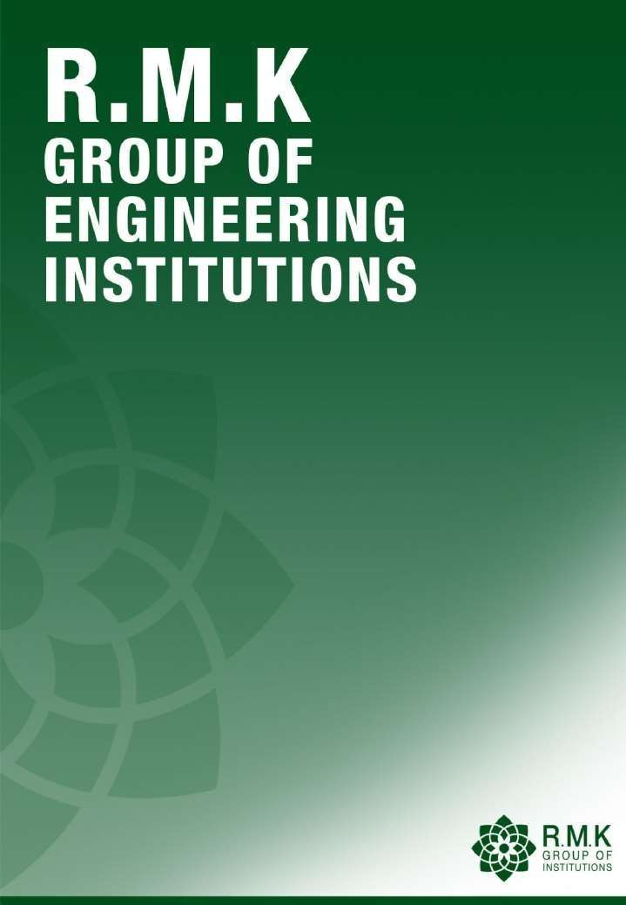

1

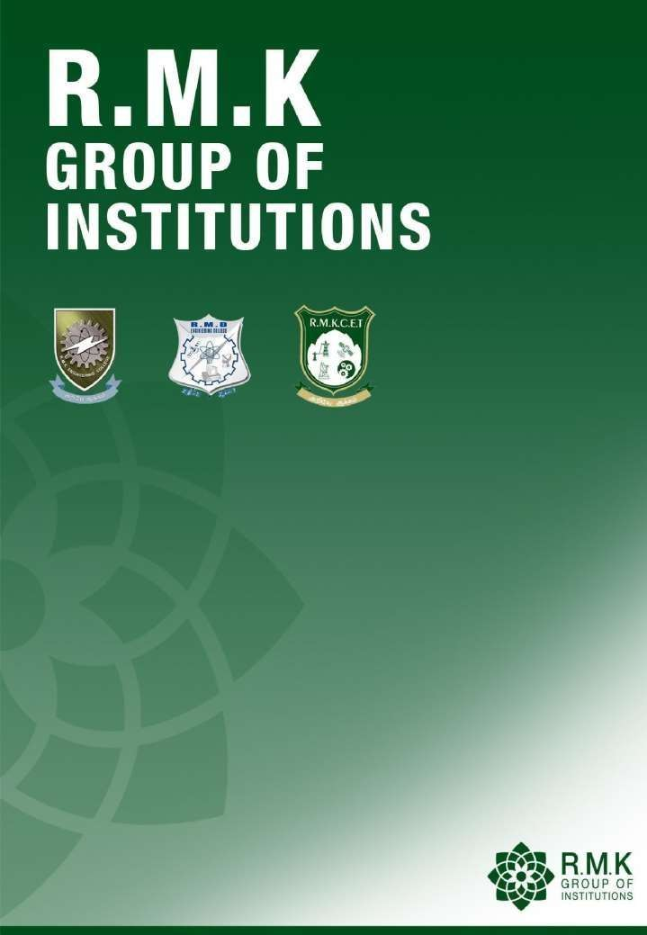

2





Please read this disclaimer before proceeding:
This document is confidential and intended solely for the educational purpose of RMK Group of Educational Institutions. If you have received this document through email in error, please notify the system manager. This document contains proprietary information and is intended only to the respective group / learning community as intended. If you are not the addressee you should not disseminate, distribute or copy through e-mail. Please notify the sender immediately by e-mail if you have received this document by mistake and delete this document from your system. If you are not the intended recipient you are notified that disclosing, copying, distributing or taking any action in reliance on the contents of this information is strictly prohibited.

3



24CS102
SOFTWARE DEVELOPMENT PRACTICES

Batch/Year/Semester: 2025-29 / I / I
Created by: Subject Handling Faculty Members
R.M.K Group of Institutions

4

CONTENTS

S. No. | Contents | Page  No
1 | Contents | 5
2 | Course Objectives | 6
3 | Pre Requisites | 7
4 | Syllabus | 8
5 | Course outcomes | 11
6 | CO- PO/PSO Mapping | 12
7 | Lecture Plan | 15
8 | Activity based learning | 17
9 | Lecture Notes | 18
10 | Assignments | 68
11 | Part A Questions & Answers | 69
12 | Part B and Part C Questions | 82
13 | Supportive online Certification courses | 84
14 | Real time Applications | 85
15 | Contents beyond the Syllabus | 88
16 | Assessment Schedule | 91
17 | Prescribed Text Books & Reference Books | 92
18 | Mini Project Suggestions | 93

5

Course Objectives
  - To discuss the essence of agile development methods.
  - To set up and create a GitHub repository.
  - To create interactive websites using HTML.
  - To design interactive websites using CSS.
  - To develop dynamic web page using Java script.

6

Prerequisites

SUBJECT CODE: 24CS102
SUBJECT NAME: SOFTWARE DEVELOPMENT PRACTICES
(Theory Course with Laboratory Component)

BASIC COMPUTER KNOWLEDGE
24CS102 – SOFTWARE DEVELOPMENT PRACTICES
(Theory Course with Laboratory Component)

7

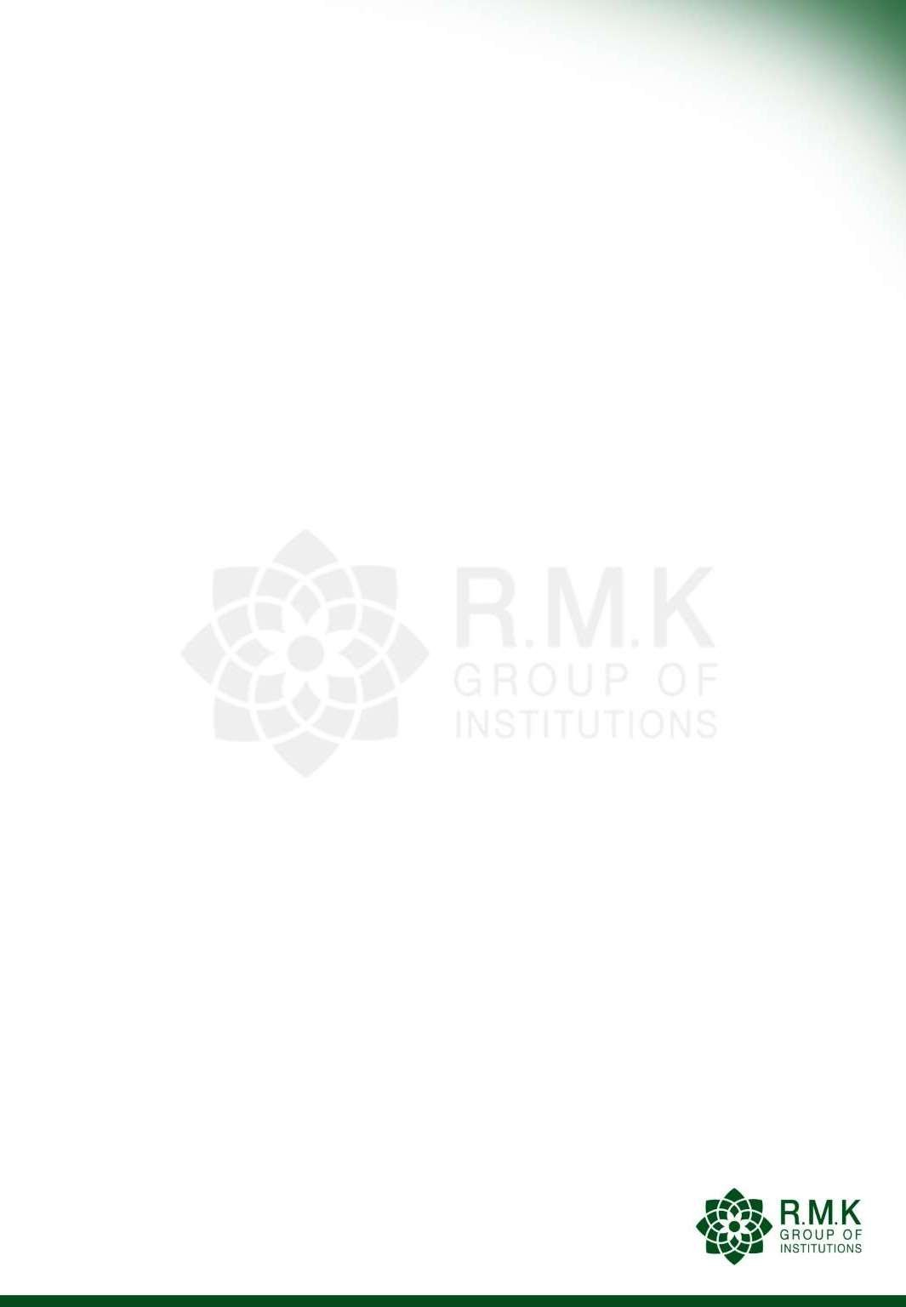
Syllabus

24CS102 | SOFTWARE DEVELOPMENT PRACTICES  (Theory Course with Laboratory Component) | L | T | P | C
24CS102 |  | 3 | 0 | 3 | 4.5
OBJECTIVES:
- To discuss the essence of agile development methods.
- To set up and create a GitHub repository.
- To create interactive websites using HTML
- To design interactive websites using CSS.
- To develop dynamic web page using Javascript.
UNIT I | AGILE SOFTWARE DEVELOPMENT, Git AND GitHub |  |  |  | 9+9
Software Engineering Practices – Waterfall Model - Agility – Agile Process –Extreme Programming - Agile Process Models –– Scrum – Crystal – Feature Driven Development – Lean Software Development – Agile Modeling – Agile Unified Process – Tool set for Agile Process.
Introduction to Git – Setting up a Git Repository - Recording Changes to the Repository - Viewing the Commit History - Undoing Things - Working with Remotes -Tagging - Git Aliases- Git Branching - Basic Branching and Merging - Branch Management - Branching Workflows - Remote Branches - Rebasing.overview of Ci/CD tools
Introduction to GitHub – Set up and Configuration - Contribution to Projects, Maintaining
a Project – Scripting GitHub.
List of Exercise/Experiments:
- Form a Team, Decide on a project:
  - Create a repository in GitHub for the team.
  - Choose and follow a Git workflow
    - Each team member can create a StudentName.txt file with contents about themselves and the team project
    - Each team member can create a branch, commit the file with a proper commit message
and push the branch to remote GitHub repository.
    - Team members can now create a Pull request to merge the branch to master branch or main development branch.
    - The Pull request can have two reviewers, one peer team member and one faculty. Reviewers can give at least one comment for Pull Request updating.
    - Once pull request is reviewed and merged, the master or main development branch will
have files created by all team members.
2. Create a web page with at least three links to different web pages. Each of the web pages is to be designed by a team member. Follow Git workflow, pull request and peer reviews.

8

UNIT II | HTML | 9+9
Introduction – Web Basics – Multitier Application Architecture – Client Side Scripting versus Server-side Scripting – HTML5 – Headings – Linking – Images– Special Characters and Horizontal Rules – Lists – Tables – Forms – Internal Linking – meta Elements – Form input Types – input and datalist Elements – Page-Structure Elements.
List of Exercise/Experiments:
- Create web pages using the following:
  - Tables and Lists
  - Image map
  - Forms and Form elements
  - Frames
UNIT III | CSS | 9+9
Inline Styles – Embedded Style Sheets – Conflicting Styles – Linking External Style Sheets
- Positioning Elements – Backgrounds – Element Dimensions – Box Model and Text Flow
- Media Types and Media Queries – Drop-Down Menus – Text Shadows – Rounded Corners – Colour – Box Shadows – Linear Gradients – Radial Gradients – Multiple Background Images – Image Borders – Animations – Transitions and Transformations – Flexible Box Layout Module – Multicolumn Layout.
List of Exercise/Experiments:
1. Apply Cascading style sheets for the web pages created.
UNIT IV | JAVASCRIPT BASICS | 9+9
Introduction to Scripting – Obtaining user input – Memory Concepts – Arithmetic – Decision Making: Equality and Relational Operators – JavaScript Control Statements – Functions – Program Modules – Programmer-defined functions – Scope rules – functions – Recursion – Arrays – Declaring and Allocating Arrays – References and Reference Parameters – Passing Arrays to Functions – Multidimensional arrays.
List of Exercise/Experiments:
1. Form Validation (Date, Email, User name, Password and Number validation) using JavaScript.
UNIT V | JAVASCRIPT OBJECTS | 9+9
Objects – Math, String, and Date, Boolean and Number, document Object – Using JSON to Represent objects – DOM: Objects and Collections – Event Handling.
List of Exercise/Experiments:
Implement Event Handling in the web pages.
Mini Projects : Develop any one of the following web applications (not limited to one)
using above technologies.
- Online assessment system
- Ticket reservation system
- Online shopping
- Student management system

9

- Student result management system
- Library management
- Hospital management
- Attendance management system
- Examination automation system
- Web based chat application
TOTAL: 45(L)+45(P)=90 PERIODS
OUTCOMES:
At the end of this course, the students will be able to:
CO1: Understand basic software engineering practices effectively.
CO2: Apply version control using Git and GitHub, and manage code repositories proficiently. CO3: Design web applications using HTML, CSS, and JavaScript.
CO4: Analyze problems and create solutions using CSS for better web page presentation and usability.
CO5: Develop interactive web pages using JavaScript with an event-handling mechanism. CO6: Apply the technological changes and improve skills continuously.
TEXT BOOKS:
- Roger S. Pressman, “Software Engineering: A Practitioner‘s Approach”, McGraw Hill International Edition, Ninth Edition, 2020.
- Scott Chacon, Ben Straub, “Pro GIT”, Apress Publisher, 3rd Edition, 2014.
- Deitel and Deitel and Nieto, “Internet and World Wide Web - How to Program”, Pearson, 5th Edition, 2018.
REFERENCES:
- Roman Pichler, “Agile Product Management with Scrum Creating Products that Customers Love”, Pearson Education, 1st Edition, 2010.
- Jeffrey C and Jackson, “Web Technologies A Computer Science Perspective”, Pearson Education, 2011.
- Stephen Wynkoop and John Burke, “Running a Perfect Website”, QUE,
2nd Edition, 1999.
- Chris Bates, “Web Programming – Building Intranet Applications”, 3rd Edition, Wiley Publications, 2009.
- Gopalan N.P. and Akilandeswari J., “Web Technology”, Second Edition, Prentice Hall of India, 2014.
- https://infyspringboard.onwingspan.com/web/ en/app/toc/ lex_auth_013382690411003904735_shared/overview
- https://infyspringboard.onwingspan.com/web/e n/app/ toc/lex_auth_0130944214274703362099_share d/overview

LIST OF EQUIPMENTS:
  - Systems with either Netbeans or Eclipse
  - Java/JSP/ISP Webserver/Apache
  - Tomcat / MySQL / Dreamweaver or
  - Equivalent/ Eclipse, WAMP/XAMP
10

Course Outcomes

COURSE OUTCOMES |  |  |  |  | HKL
CO1 |  | Understand basic software engineering practices effectively. |  |  | K2
CO2 |  | Apply version control using Git and GitHub, and manage code repositories proficiently. |  |  | K3
CO3 |  | Design web applications using HTML, CSS, and JavaScript. |  |  | K3
CO4 |  | Analyze problems and create solutions using CSS for better web page presentation and usability. |  |  | K4
CO5 |  | Develop interactive web pages using JavaScript with an event-handling  mechanism. |  |  | K6
CO6 |  | Apply the technological changes and improve skills continuously |  |  | K6
 | Knowledge Level |  | Description
 | K6 |  | Evaluation
 | K5 |  | Synthesis
 | K4 |  | Analysis
 | K3 |  | Application
 | K2 |  | Comprehension
 | K1 |  | Knowledge

11

CO-PO/PSO Mapping

CO | CO ATTAIN MENT | PROGRAM OUTCOMES |  |  |  |  |  |  |  |  |  |  | PROGRAM SPECIFIC OUTCOMES
CO | CO ATTAIN MENT | PO 1 | PO 2 | PO 3 | PO 4 | PO  5 | PO 6 | PO 7 | PO 8 | PO 9 | PO 10 | PO 11 | P S 0  1 | P S 0  2 | P S 0  3
CO1 | 1 | 3 | 3 | 3 | 1 | 1 | 1 | - | - | 2 | 1 | 2 | - | - | -
CO2 | 2 | 3 | 2 | 3 | 1 | 1 | 1 | - | 1 | 2 | 1 | 2 | - | - | -
CO3 | 3 | 3 | 3 | 3 | 1 | 2 | 1 | - | 1 | 2 | 1 | 2 | - | - | -
CO4 | 4 | 3 | 3 | 3 | 1 | 2 | 1 | - | 1 | 2 | 1 | 2 | - | - | -
CO5 | 5 | 3 | 3 | 3 | 1 | 2 | 1 | - | 1 | 2 | 1 | 2 | - | - | -
CO6 | 6 | 3 | 2 | 3 | 1 | 2 | 1 | - | 1 | 2 | 1 | 2 | - | - | -
CO |  | 3 | 3 | 3 | 1 | 2 | 1 | - | 1 | 2 | 1 | 2 | - | - | -

12

Program Outcomes (POs)
PO1: Engineering Knowledge: Apply knowledge of mathematics, natural science, computing, engineering fundamentals and an engineering specialization as specified in WK1 to WK4 respectively to develop to the solution of complex engineering problems.
PO2: Problem Analysis: Identify, formulate, review research literature and analyse complex engineering problems reaching substantiated conclusions with consideration for sustainable development. (WK1 to WK4)
PO3: Design/Development of Solutions: Design creative solutions for complex engineering problems and design/develop systems/components/processes to meet identified needs with consideration for the public health and safety, whole-life cost, net zero carbon, culture, society and environment as required. (WK5)
PO4: Conduct Investigations of Complex Problems: Conduct investigations of complex engineering problems using research-based knowledge including design of experiments, modelling, analysis & interpretation of data to provide valid conclusions. (WK8).
PO5: Engineering Tool Usage: Create, select and apply appropriate techniques, resources and modern engineering & IT tools, including prediction and modelling recognizing their limitations to solve complex engineering problems. (WK2 and WK6)
PO6: The Engineer and The World: Analyse and evaluate societal and environmental aspects while solving complex engineering problems for its impact on sustainability with reference to economy, health, safety, legal framework, culture and environment. (WK1, WK5, and WK7).
PO7: Ethics: Apply ethical principles and commit to professional ethics, human values, diversity and inclusion; adhere to national & international laws. (WK9)
PO8: Individual and Collaborative Team work: Function effectively as an
individual, and as a member or leader in diverse/multi-disciplinary teams.
PO9: Communication: Communicate effectively and inclusively within the engineering community and society at large, such as being able to comprehend and write effective reports and design documentation, make effective presentations considering cultural, language, and learning differences
PO10: Project Management and Finance: Apply knowledge and understanding of engineering management principles and economic decision-making and apply these to one’s own work, as a member and leader in a team, and to manage projects and in multidisciplinary environments.
PO11: Life-Long Learning: Recognize the need for, and have the preparation and ability for i) independent and life-long learning ii) adaptability to new and emerging technologies and iii) critical thinking in the broadest context of technological change. (WK8)

13

Knowledge and Attitude Profile (WK)
WK1 : A systematic, theory-based understanding of the natural sciences applicable to the discipline and awareness of relevant social sciences.
WK2 : Conceptually-based mathematics, numerical analysis, data analysis, statistics and formal aspects of computer and information science to support detailed analysis and modelling applicable to the discipline.
WK3 : A systematic, theory-based formulation of engineering fundamentals required in the engineering discipline.
WK4 : Engineering specialist knowledge that provides theoretical frameworks and bodies of knowledge for the accepted practice areas in the engineering discipline; much is at the forefront of the discipline.
WK5 : Knowledge, including efficient resource use, environmental impacts, whole-life cost, re-use of resources, net zero carbon, and similar concepts, that supports engineering design and operations in a practice area.
WK6 : Knowledge of engineering practice (technology) in the practice areas in the engineering discipline.
WK7 : Knowledge of the role of engineering in society and identified issues in engineering practice in the discipline, such as the professional responsibility of an engineer to public safety and sustainable development.
WK8 : Engagement with selected knowledge in the current research literature of the discipline, awareness of the power of critical thinking and creative approaches to evaluate emerging issues.
WK9 : Ethics, inclusive behavior and conduct. Knowledge of professional ethics, responsibilities, and norms of engineering practice. Awareness of the need for diversity by reason of ethnicity, gender, age, physical ability etc. with mutual understanding and respect, and of inclusive attitudes.

14

LECTURE PLAN : UNIT – I

AGILE SOFTWARE DEVELOPMENT AND GIT AND GITHUB

UNIT – I AGILE SOFTWARE DEVELOPMENT AND Git and GitHub9
S.  No | Proposed Lecture Date | Topic | Actual Lecture Date | CO | Highest Cognitive Level | Mode of  Delivery | LU Outcomes
1 | 11.09.2025 | Software Engineering Practices,  Waterfall Model, Agility, Agility  Process |  | CO 1 | K3 | MD1, MD4 &  MD5 | Software Engineering Practices, Waterfall Model, Agility, Agility Process
2 | 12.09.2025 | Extreme Programming, Agile Process Models, Adaptive Software Development, Scrum |  | CO 1 | K3 | MD1, MD4,  & MD5 | Extreme Programming, Agile Process Models, Adaptive Software Development, Scrum
3 | 13.09.2025 | Dynamic Systems Development Method, Crystal, Feature Driven Development |  | CO 1 | K3 | MD1, MD4, &  MD5 | Dynamic Systems Development Method, Crystal, Feature Driven Development
4 | 15.9.2025 | Lean Software  Development, Agile Modeling |  | CO 1 | K3 | MD1, MD4, & MD5 | Lean Software Development, Agile Modeling
5 | 16.09.2025 | Agile Unified Process, Tool set  for Agile Process |  | CO 1 | K3 | MD1, MD4, & MD5 | Agile Unified Process, Tool set for Agile Process
6 | 17.09.2025 | Introduction to Git, Setting up a Git Repository |  | CO 1 | K6 | MD1, MD4, & MD5 | Introduction to Git, Setting up a Git Repository
7 | 18.09.2025 | Recording Changes to the Repository |  | CO 1 | K6 | MD1, MD4 & MD5 | Recording Changes to the Repository
8 | 19.09.2025 | Viewing the Commit History |  | CO 1 | K6 | MD1, MD4 &  MD5 | Viewing the Commit History
9 | 20.09.2025 | Undoing Things, Working with Remotes, Tagging |  | CO 1 | K6 | MD1, MD4, & MD5 | Undoing Things, Working with Remotes, Tagging
10 | 22.09.2025 | Git Aliases, Git Branching, Branches in a Nutshell |  | CO 1 | K6 | MD1, MD4, & MD5 | Git Aliases, Git Branching, Branches in a Nutshell
11 | 23.09.2025 | Basic Branching and Merging |  | CO 1 | K6 | MD1, MD4, & MD5 | Basic Branching and Merging
12 | 24.09.2025 | Branch Management,  Branching Workflows |  | CO 1 | K6 | MD1, MD4, & MD5 | Branch Management,  Branching Workflows
13 | 25.09.2025 | Remote Branches, Rebasing, Introduction to GitHub |  | CO 1 | K  K6 | MD1, MD4, & MD5 | Remote Branches, Rebasing, Introduction to GitHub
14 | 11.09.2025 | Set up and Configuration,  Contribution to Projects |  | CO 1 | K6 | MD1, MD4,  & MD5 | Set up and Configuration,  Contribution to Projects
15 | 26.09.2025 | Maintaining a Project, Scripting GitHub |  | CO 1 | K6 | MD1, MD4, & MD5 | Maintaining a Project, Scripting GitHub

15

  - ASSESSMENT COMPONENTS
    - AC 1. Unit Test
    - AC 2. Assignment
    - AC 3. Course Seminar
    - AC 4. Course Quiz
    - AC 5. Case Study
    - AC 6. Record Work
    - AC 7. Lab / Mini Project
    - AC 8. Lab Model Exam
    - AC 9. Project Review

- MODE OF DELEIVERY
  - MD 1. Oral presentation
  - MD 2. Tutorial
  - MD 3. Seminar
  - MD 4. Hands On
  - MD 5. Videos
  - MD 6. Field Visit

16

8. ACTIVITY BASED LEARNING : UNIT – I

MIND MAP FOR UNDERSTANDING SOFTWARE ENGINEERING PRACTICES AND GIT AND GITHUB
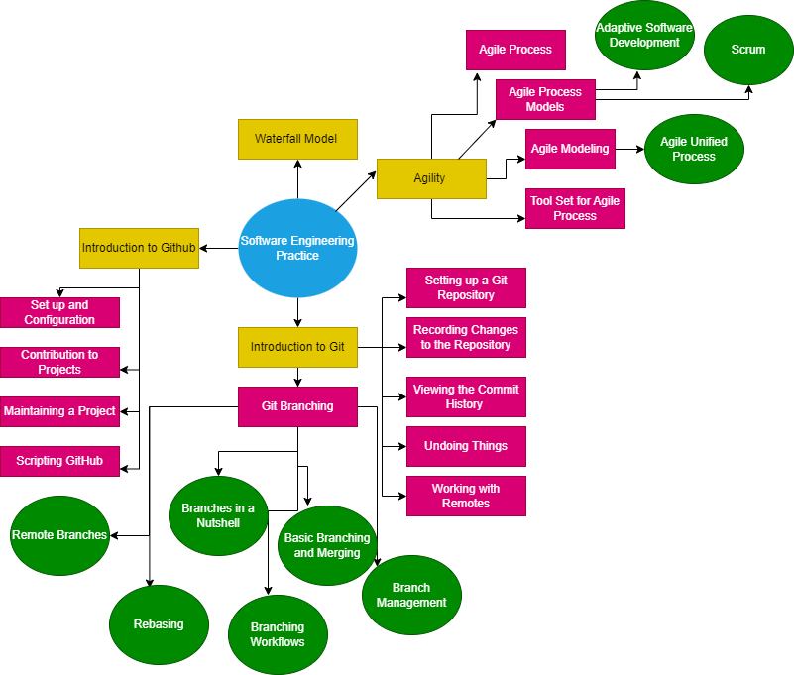

17

Lecture Notes - Unit I
Agile Software Development, Git and
GitHub

18

Syllabus

UNIT I | AGILE SOFTWARE DEVELOPMENT, Git AND GitHub | 9+9
Software Engineering Practices – Waterfall Model - Agility – Agile Process – Extreme Programming - Agile Process Models – Adaptive Software Development – Scrum – Dynamic Systems Development Method – Crystal – Feature Driven Development – Lean Software Development – Agile Modeling – Agile Unified Process – Tool set for Agile Process.
Introduction to Git – Setting up a Git Repository - Recording Changes to the Repository- Viewing the Commit History - Undoing Things - Working with Remotes -Tagging - Git Aliases - Git Branching - Branches in a Nutshell - Basic Branching and Merging - Branch Management - Branching Workflows - Remote Branches - Rebasing. Overview o fCI/CD toolsIntroduction to GitHub – Set up and Configuration - Contribution to Projects, Maintaining a Project –
Scripting GitHub.

19

SOFTWARE ENGINEERING PRACTICES
A Generic software process model will be composed of a set of activities that establish a framework for software engineering practice. Generic framework activities are:
- Communication
- Planning
- Modeling
- Construction
- Deployment

ESSENCE OF SOFTWARE ENGINEERNG PRACTICE
George Polya outlined the essence of problem solving and the essence of software engineering practice.
Understand the problem (communication and analysis). Plan a solution (modeling
and software design).
Carry out the plan (code generation).
Examine the result for accuracy (testing and quality assurance).

Understand the problem
Who has a stake in the solution to the problem? That is, who are the stake- holders? What are the unknowns? What data, functions, and features are required to properly solve the problem?
Can the problem be compartmentalized? Is it possible to represent smaller problems that may be easier to understand?
Can the problem be represented graphically? Can an analysis model be created?

Plan the solution
Have you seen similar problems before?
Has a similar problem been solved? If so, are elements of the solution reusable? Can sub problems be defined? If so, are solutions readily apparent for the sub
problems?
Can you represent a solution in a manner that leads to effective implementation? Can a design model be created?

20

Carry out the plan
Does the solution conform to the plan? Is source code traceable to the design model?
Is each component part of the solution provably correct? Have the design and code been reviewed, or better, have correctness proofs been applied to the algorithm?

Examine the result
Is it possible to test each component part of the solution? Has a reasonable testing strategy been implemented?
Does the solution produce results that conform to the data, functions, and features
that are required? Has the software been validated against all stakeholder
requirements?

GENERAL PRINCIPLES OF SOFTWARE ENGINEERING PRACTICES

The First Principle: The Reason It All Exists
“Does this add real value to the system?” If the answer is “no,” don’t do it. All other principles support this one.

The Second Principle: KISS (Keep It Simple, Stupid!)
All design should be as simple as possible but no simpler.

The Third Principle: Maintain the Vision
A clear vision is essential to the success of a software project.

The Fourth Principle: What You Produce, Others Will Consume
Always specify, design, and implement knowing someone else will have to understand
what you are doing.

The Fifth Principle: Be Open to the Future
Never design yourself into a corner.

The Sixth Principle: Plan Ahead for Reuse
Reduces the cost and increases the value of both the reusable components and the systems into which they are incorporated.

The Seventh principle: Think!
Placing clear, complete thought before action almost always produces better results.

21

Software Development Life Cycle (SDLC) MODELS
There are various software development life cycle models defined and designed which are followed during the software development process.
These models are also referred as "Software Development Process Models".
Each process model follows a Series of steps unique to its type to ensure success in the process of software development.
Example: Waterfall Model, Iterative Model, Spiral Model, V-Model, Big Bang Model.

WATERFALL MODEL
It is a SDLC Model. It is also called Linear-sequential life cycle model.
This classic model divides the life cycle into a set of phases. The output of one phase will be the input to the next phase. Thus the development process can be considered as a sequential flow in the waterfall. Here the phases do not overlap with each other. It is also called Linear-sequential life cycle model.
It is used when the requirements for a problem are well understood—when work flows from communication through deployment in a reasonably linear fashion. This situation is sometimes encountered when well-defined adaptations or enhancements to an existing system must be made.
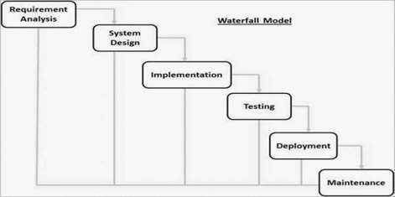
Fig. Waterfall model

22

LIFE CYCLE PHASES OF WATERFALL MODEL: REQUIREMENT GATHERING AND ANALYSIS
All possible requirements of the system to be developed are captured in this
phase and documented in a requirement specification document.

SYSTEM DESIGN
The requirement specifications from first phase are studied in this
phase and the system design is prepared. This system design helps in specifying hardware and system requirements and helps in defining the overall system architecture.

IMPLEMENTATION
With inputs from the system design, the system is first developed in
small programs called units, which are integrated in the next phase. Each unit is developed and tested for its functionality, which is referred to as Unit Testing.

INTEGRATION AND TESTING
All the units developed in the implementation phase are integrated
into a system after testing of each unit. Post integration the entire system is tested for any faults and failures.

DEPLOYMENT OF SYSTEM
Once the functional and non-functional testing is done; the product is deployed in the customer environment or released into the market.

MAINTENANCE
There are some issues which come up in the client environment. To
fix those issues, patches are released. Also to enhance the product some better versions are released. Maintenance is done to deliver these changes in the customer environment.

APPLICATIONS OF WATERFALL MODEL
Requirements are very well documented, clear and fixed. Product definition is stable.
Technology is understood and is not dynamic.

23

Ample resources with required expertise are available to support the product.
The project is short.

ADVANTAGES:
Simple and easy to understand and use.
Easy to manage due to the rigidity of the model. Each phase has specific
deliverables and a review process.
Phases are processed and completed one at a time.
Works well for smaller projects where requirements are very well understood. Clearly defined stages.
Well understood milestones. Easy to arrange tasks.
Process and results are well documented.

DISADVANTAGES:
No working software is produced until late during the life cycle. High amounts of risk and uncertainty.
Not a good model for complex and object-oriented projects. Poor model for long and ongoing projects.
Not suitable for the projects where requirements are at a moderate to high risk
of changing. So, risk and uncertainty is high with this process model.
It is difficult to measure progress within stages. Cannot accommodate changing requirements.
Adjusting scope during the life cycle can end a project.
Integration is done as a "big-bang" at the very end, which doesn't allow identifying any technological or business bottleneck or challenges early.

24

AGILITY

The meaning of the word “agility” is ability to move your body quickly and easily or nimbleness.
An agile team is a nimble team able to appropriately respond to changes. Change is what software development is very much about. Changes in the software being built, changes to the team members, changes because of new technology, changes of all kinds that may have an impact on the product they build or the project that creates the product. Support for changes should be built-in everything we do in software.
An agile team recognizes that software is developed by individuals working in teams and that the skills of these people, their ability to collaborate is at the core for the success of the project.
Agility can be applied to any software process. However, to accomplish this, it is essential that the process be designed in a way that allows the project team to adapt tasks and to streamline them, conduct planning in a way that understands the fluidity of an agile development approach, eliminate all but the most essential work products and keep them lean, and emphasize an incremental delivery strategy that gets working software to the customer as rapidly as feasible for the product type and operational environment.

AGILITY AND COST OF CHANGE
The cost of change increases nonlinearly as a project progresses (solid black curve). It is relatively easy to accommodate a change when a software team is gathering requirements.
A well-designed agile process “flattens” the cost of change curve ( shaded, solid curve), allowing a software team to accommodate changes late in a software project without dramatic cost and time impact.

25

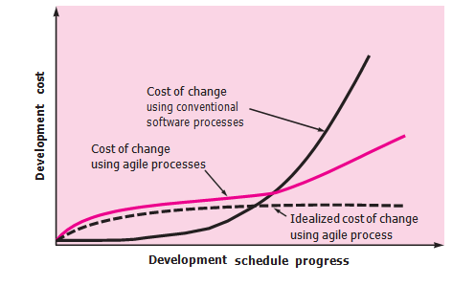
Fig. Agility and cost of change

AGILE PROCESS
Any agile process will be characterized by the following number of key
assumptions: It is difficult to predict in advance which software requirements will persist and which will change. It is equally difficult to predict how customer priorities will change as the project proceeds.
For many types of software, design and construction are interleaved. That is, both activities should be performed in tandem so that design models are proven as they are created. It is difficult to predict how much design is necessary before construction is used to prove the design.
Analysis, design, construction, and testing are not as predictable (from a planning point of view) as we might like.
An incremental development strategy should be instituted. Software increments (executable prototypes or portions of an operational system) must be delivered in short time periods so that adaptation keeps pace with change (unpredictability).
This iterative approach enables the customer to evaluate the software increment regularly, provide necessary feedback to the software team, and influence the process adaptations that are made to accommodate the feedback.

26

AGILITY PRINCIPLES
Our highest priority is to satisfy the customer through early and continuous delivery of valuable software.
Welcome changing requirements, even late in development. Agile processes harness change for the customer’s competitive advantage.
Deliver working software frequently, from a couple of weeks to a couple of months,
with a preference to the shorter timescale.
Business people and developers must work together daily throughout the project.
Build projects around motivated individuals. Give them the environment and support they need, and trust them to get the job done.
The most efficient and effective method of conveying information to and within a development team is face-to-face conversation.
Working software is the primary measure of progress.
Agile processes promote sustainable development. The sponsors, developers, and users should be able to maintain a constant pace indefinitely.
Continuous attention to technical excellence and good design enhances agility.
Simplicity—the art of maximizing the amount of work not done—is essential.
The best architectures, requirements, and designs emerge from self–organizing teams.
At regular intervals, the team reflects on how to become more effective, then tunes
and adjusts its behavior accordingly.

AGILE MANIFESTO
Individuals and interactions over processes and tools. Working software over comprehensive documentation. Customer collaboration over contract negotiation.
Responding to change over following a plan.

27

HUMAN FACTORS
If members of the software team are to drive the characteristics of the process that is applied to build software, a number of key traits must exist among the people on an agile team and the team itself:
Competence. In an agile development (as well as software engineering) context, “competence” encompasses innate talent, specific software-related skills, and overall knowledge of the process that the team has chosen to apply. Skill and knowledge of process can and should be taught to all people who serve as agile team members.
Common focus. Although members of the agile team may perform different tasks and bring different skills to the project, all should be focused on one goal to deliver a working software increment to the customer within the time promised. To achieve this goal, the team will also focus on continual adaptations (small and large) that will make the process fit the needs of the team.
Collaboration. Software engineering (regardless of process) is about assessing, analyzing, and using information that is communicated to the software team; creating information that will help all stakeholders understand the work of the team; and building information (computer software and relevant databases) that provides business value for the customer. To accomplish these tasks, team members must collaborate with one another and all other stakeholders.
Decision-making ability. Any good software team (including agile teams) must be allowed the freedom to control its own destiny. This implies that the team is given autonomy—decision-making authority for both technical and project issues.

28

Fuzzy problem-solving gibility. Software managers must recognize that the agile team will continually have to deal with ambiguity and will continually be buffeted by change. In some cases, the team must accept the fact that the problem they are solving today may not be the problem that needs to be solved tomorrow. However, lessons learned from any problem-solving activity (including those that solve the wrong problem) may be of benefit to the team later in the project.

Mutual trust and respect.
A jelled team exhibits the trust and respect that are necessary to make them “so strongly knit that the whole is greater than the sum of the parts.”
Self-organization. In the context of agile development, self-organization implies three things.

The agile team organizes itself for the work to be done.

The team organizes the process to best accommodate its local environment.
The team organizes the work schedule to best achieve delivery of the software increment.
Self-organization has a number of technical benefits, but more importantly, it serves to improve collaboration and boost team morale.
In essence, the team serves as its own management. The team selects how much work it believes it can perform within the iteration, and the team commits to the work. Nothing demotivates a team as much as someone else making commitments for it. Nothing motivates a team as much as accepting the
responsibility for fulfilling commitments that it made itself

29

EXTREME PROGRAMMING

Extreme Programming (XP), the most widely used approach to agile software development.
A variant of XP, called Industrial XP (IXP) has been proposed. IXP refines XP and targets the agile process specifically for use within large organizations.

XP VALUES
A set of five values that establish a foundation for all work performed as part of XP
- Communication

- Simplicity
- Feedback

- Courage

- Respect

COMMUNICATION: XP emphasizes close, yet informal (verbal) collaboration between customers and developers, the establishment of effective metaphors for communication important concepts, continuous feedback, and the avoidance of voluminous documentation as a communication medium.
SIMPLICITY: XP restricts developers to design only for immediate needs, rather than consider future needs. If the design must be improved, it can be refactored at a later time.
FEEDBACK is derived from three sources the implemented software itself, the customer, and other software team members. As each class is developed, the team develops a unit test to exercise each operation according to its specified functionality. As an increment is delivered to a customer, the user stories or use cases that are implemented by the increment are used as a basis for acceptance tests. The degree to which the software implements the output, function, and behavior of the use case is a form of feedback.

30

Finally, as new requirements are derived as part of iterative planning, the team provides the customer with rapid feedback regarding cost and schedule impact.
COURAGE: An agile XP team must have the discipline (courage) to design for today, recognizing that future requirements may change dramatically, thereby demanding substantial rework of the design and implemented code.
RESPECT:As they achieve successful delivery of software increments, the team develops growing respect for the XP process
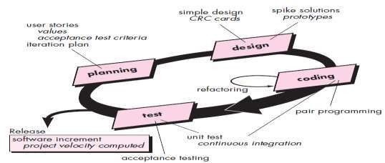

Fig. Extreme Programming

1.4.2 XP PROCESS
Extreme Programming uses an object-oriented approach.
Planning. The planning activity begins with listening a requirements gathering activity that enables the technical members of the XP team to understand the business context for the software and to get a broad. feel for required output and major features and functionality. Listening leads to the creation of a set of “stories” (user stories) that describe required output, features, and functionality for software to be built. Each story is written by the customer and is placed on an index card. The customer assigns a value (i.e., a priority) to the story based on the overall business value of the feature or function.

31

Members of the XP team then assess each story and assign a cost measured in development weeks to it. If the story is estimated to require more than three development weeks, the customer is asked to split the story into smaller stories and the assignment of value and cost occurs again. It is important to note that new stories can be written at any time.
Once a basic commitment (agreement on stories to be included, delivery date, and other project matters) is made for a release, the XP team orders the stories that will be developed in one of three ways:
All stories will be implemented immediately (within a few weeks).
The stories with highest value will be moved up in the schedule and implemented first.
The riskiest stories will be moved up in the schedule and implemented first.
After the first project release (also called a software increment) has been delivered.
Project velocity is the number of customer stories implemented during the first release.
Project velocity can then be used to help estimate delivery dates and schedule for subsequent releases.
Determine whether an over commitment has been made for all stories across the entire development project. If an over commitment occurs, the content of releases is modified or end delivery dates are changed.

32

Design
XP encourages the use of CRC cards as an effective mechanism for thinking
about the software in an object-oriented context. CRC (class-responsibility- collaborator)cards identify and organize the object-oriented classes that are relevant to the current software increment.
The CRC cards are the only design work product produced as part of the XP process.
If a difficult design problem is encountered as part of the design of a story, XP recommends the immediate creation of an operational prototype of that portion of the design Called a spike solution, the design prototype is implemented and evaluated.
The intent is to lower risk when true implementation starts and to validate the original estimates for the story containing the design problem.

Coding
After stories are developed and preliminary design work is done, the team does not move to code, but rather develops a series of unit tests that will exercise each of the stories that is to be included in the current release (software increment).
Once the unit test has been created, the developer is better able to focus on what must be implemented to pass the test. Nothing extraneous is added .
Once the code is complete, it can be unit-tested immediately, thereby providing instantaneous feedback to the developers.
As pair programmers complete their work, the code they develop is integrated with the work of others. In some cases this is performed on a daily basis by an integration team.

33

Testing
As the individual unit tests are organized into a “universal testing suite”
Integration and validation testing of the system can occur on a daily basis. This provides the XP team with a continual indication of progress and also can raise warning flags early if things go awry.
XP acceptance tests, also called customer tests, are specified by the customer and focus on overall system features and functionality that are visible and reviewable by the customer. Acceptance tests are derived from user stories that have been implemented as part of a software release.

1.4.3 INDUSTRIAL XP
IXP is an organic evolution of XP. IXP incorporates six new practices that are designed to help ensure that an XP project works successfully for significant projects within a large organization.
Readiness assessment. Prior to the initiation of an IXP project, the organization should conduct a readiness assessment. The assessment ascertains
- An appropriate development environment exists to support IXP

- The team will be populated by the proper set of stakeholders
- The organization has a distinct quality program and supports continuous improvement
- The organizational culture will support the new values of an agile team

- The broader project community will be populated appropriately.
Project community. A community may have a technologist and customers who are central to the success of a project as well as many other stakeholders (e.g., legal staff, quality auditors, manufacturing or sales types).

34

In IXP, the community members and their roles should be explicitly defined and mechanisms for communication and coordination between community members should be established.
Project chartering. The IXP team assesses the project itself to determine whether an appropriate business justification for the project exists and whether the project will further the overall goals and objectives of the organization.
Test-driven management. Test-driven management establishes a series of measurable “destinations "and then defines mechanisms for determining whether or not these destinations have been reached.
Retrospectives. The review examines “issues, events, and lessons-learned” across a software increment and/or the entire software release. The intent is to improve the IXP process.

AGILE PROCESS MODELS

- Adaptive Software Development (ASD)
- Scrum
- Dynamic Systems Development Method (DSDM)
- Crystal
- Feature Drive Development (FDD)
- Lean Software Development (LSD)
- Agile Modeling (AM)
- Agile Unified Process (AUP)

35

ADAPTIVE SOFTWARE DEVELOPMENT (ASD)

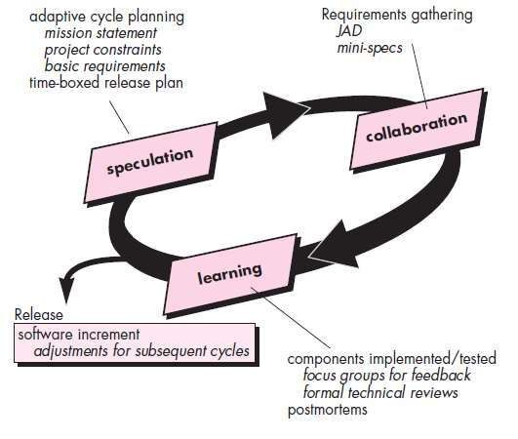

Fig. Adaptive Software Development
ASD life cycle incorporates three phases -speculation, collaboration, and
learning.

Speculation
During speculation, the project is initiated and adaptive cycle planning is conducted.

36

Adaptive cycle planning uses project initiation information—the customer’s mission statement, project constraints (e.g., delivery dates or user descriptions), and basic requirements to define the set of release cycles (software increments) that will be required for the project.
No matter how complete and farsighted the cycle plan, it will invariably change.

Based on information obtained at the completion of the first cycle, the plan is
reviewed.
And adjusted so that planned work better fits the reality in which an ASD team is working.

Collaboration

People working together must trust one another to
- Criticize without animosity

- Assist without resentment
- Work as hard as or harder than they do
- Have the skill set to contribute to the work at hand
- Communicate problems or concerns in a way that leads to effective action.

Learning
learning will help them to improve their level of real understanding. SD teams learn in three ways: focus groups, technical reviews and project postmortems.

Merit
ASD’s overall emphasis on the dynamics of self-organizing teams, interpersonal collaboration, and individual and team learning yield software project teams that have a much higher likelihood of success.

37

SCRUM
Scrum principles are consistent with the agile manifesto and are used to guide development activities within a process that incorporates the following framework activities: requirements, analysis, design, evolution, and delivery.
Within each framework activity, work tasks occur within a process pattern called a sprint. The work conducted within a sprint is adapted to the problem at hand and is defined and often modified in real time by the Scrum team.
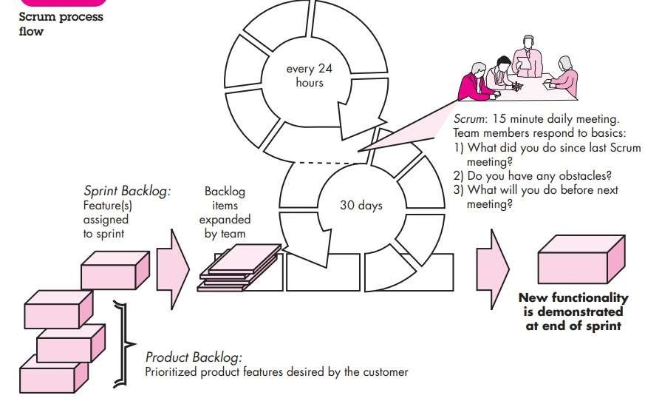
Fig. Scrum
Scrum emphasizes the use of a set of software process patterns. Each of these

process patterns defines a set of development actions.
Backlog a prioritized list of project requirements or features that provide business value for the customer. Items can be added to the backlog at any time (this is how changes are introduced). The product manager assesses the backlog and updates priorities as required.

38

Sprints consist of work units that are required to achieve a requirement defined in the backlog that must be fit into a predefined time-box(typically 30 days)
Changes (e.g., backlog work items) are not introduced during the sprint. Hence, the sprint allows team members to work in a short-term, but stable environment.
Scrum meetings are short (typically 15 minutes) meetings held daily by the Scrum team.
Three key questions are asked and answered by all team members

- What did you do since the last team meeting?

- What obstacles are you encountering?
- What do you plan to accomplish by the next team meeting?

A team leader, called a Scrum master, leads the meeting and assesses the responses from each person. The Scrum meeting helps the team to uncover potential problems as early as possible
Demos—deliver the software increment to the customer so that functionality that
has been implemented can be demonstrated and evaluated by the customer.

DYNAMIC SYSTEMS DEVELOPMENT METHOD (DSDM)
DSDM is an iterative software process in which each iteration follows the 80 percent rule. That is, only enough work is required for each increment to facilitate movement to the next increment. The remaining detail can be completed later when more business requirements are known or changes have been requested and accommodated.
DSDM life cycle defines three different iterative cycles, preceded by two additional life cycle activities:

39

- Feasibility study

- Business study
- Functional model iteration
- Design and build iteration
- Implementation
Feasibility study establishes the basic business requirements and constraints associated with the application to be built and then assesses whether the application is a viable candidate for the DSDM process.
Business study establishes the functional and information requirements that will allow the application to provide business value; also, defines the basic application architecture and identifies the maintainability requirements for the application.
Functional model iteration produces a set of incremental prototypes that demonstrate functionality for the customer. (Note: All DSDM prototypes are intended to evolve into the deliverable application.) The intent during this iterative cycle is to gather additional requirements by eliciting feedback from users as they exercise the prototype.
Design and build iteration revisits prototypes built during functional model iteration to ensure that each has been engineered in a manner that will enable it to provide operational business value for end users. In some cases, functional model iteration and design and build iteration occur concurrently
Implementation places the latest software increment (an “operationalized” prototype) into the operational environment.
- the increment may not be 100 percent complete or
- changes may be requested as the increment is put into place.
In either case, DSDM development work continues by returning to the functional model iteration activity.
40

CRYSTAL

Crystal agile methodologies emphasize the importance of tailoring project management practices to the unique needs of each team and project.The crystal agile method recognizes that no single approach fits all situations, and instead provides a set of principles and practices that can be adapted to suit specific requirements.

The crystal framework in agile development is characterized by its focus on:
Frequent delivery of working software
- Close communication within the team
- Continuous improvement through reflection and adaptation
- Minimal bureaucracy and documentation
To achieve maneuverability, Cockburn and Highsmith have defined a set of methodologies, each with core elements that are common to all, and roles, process patterns, work products, and practice that are unique to each.
The Crystal family is actually a set of example agile processes that have been proven effective for different types of projects. The intent is to allow agile teams to select the member of the crystal family that is most appropriate for their project and environment.
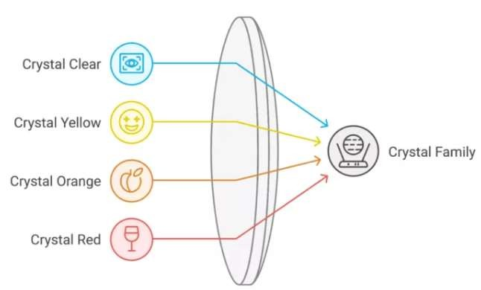

Fig. The Crystal family

41

Crystal Clear
Crystal Clear is the lightest and most agile of the crystal methodologies, designed for small teams of up to 8 people working on low-criticality projects.
This crystal agile method emphasizes:
- Frequent delivery of working software
- Close communication among team members
- Minimal documentation
- Reflective improvement
Crystal Clear is ideal for startups or small projects where rapid development and flexibility are crucial.

Crystal Yellow

Moving up the spectrum, Crystal Yellow is suitable for teams of 10-20 members
working on projects with higher criticality.
This crystal framework in agile development introduces:
- More formal communication channels
- Increased documentation
- Specialized roles within the team
Crystal Yellow strikes a balance between agility and structure, making it suitable for medium-sized projects with moderate risk.

Crystal Orange

Crystal Orange is designed for larger teams of 20-50 members working on more
complex projects.
This crystal agile methodology incorporates:
- More rigorous planning and tracking
- Specialized teams for different project aspects
- Increased focus on risk management
Crystal Orange is well-suited for enterprise-level projects that require coordination among multiple teams.

42

FEATURE DRIVEN DEVELOPMENT (FDD)
FDD adopts a philosophy that

- Emphasizes collaboration among people on an FDD team;
- Manages problem and project complexity using feature-based decomposition followed by the integration of software increments
- Communication of technical detail using verbal, graphical, and text-based means.
The emphasis on the definition of features provides the following benefits:
Because features are small blocks of deliverable functionality, users can describe them more easily; understand how they relate to one another more readily; and better review them for ambiguity, error, or omissions.
Features can be organized into a hierarchical business-related grouping.
- Since a feature is the FDD deliverable software increment, the team develops operational features every two weeks.
- Because features are small, their design and code representations are easier to
inspect effectively.

- Project planning, scheduling, and tracking are driven by the feature hierarchy,
rather than an arbitrarily adopted software engineering task set.

43

Template for defining a feature:
<action> the <result> <by for of to> a(n) <object> where an <object> is “a person, place, or thing (including roles, moments in time or intervals of time, or catalog-entry-like descriptions).”
Examples of features for an e-commerce application might be:

- Add the product to shopping cart
- Display the technical-specifications of the product
- Store the shipping-information for the customer
A feature set groups related features into business-related categories and is
defined as

<action><-ing> a(n) <object>

For example: Making a product sale

The FDD approach defines five “collaborating” framework activities (in FDD these are called “processes”) as shown in Figure 1.5.5
FDD defines six milestones during the design and implementation of a feature:
“design walkthrough, design, design inspection, code,code inspection, promote
to build”
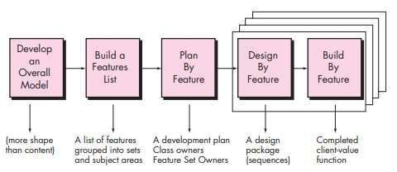
Fig. Feature Driven Development

44

LEAN SOFTWARE DEVELOPMENT (LSD)
The lean principles that inspire the LSD process can be summarized as eliminate waste, build quality in, create knowledge, defer commitment, deliver fast, respect people, and optimize the whole.
For example, eliminate waste within the context of an agile software project can be interpreted
- Adding no extraneous features or functions
- Assessing the cost and schedule impact of any newly requested requirement
- Removing any superfluous process steps
- Establishing mechanisms to improve the way team members find information
- Ensuring the testing finds as many errors as possible
- Reducing the time required to request and get a decision that affects the
- Software or the process that is applied to create it
- Streamlining the manner in which information is transmitted to all stakeholders involved in the process.

AGILE MODELING (AM)
Agile Modeling (AM) is a collection of values, principles, and practices for
modeling software that can be applied on a software development project in an effective and light-weight manner.
Although AM suggests a wide array of “core” and “supplementary” modeling
principles, those that make AM unique are Model with a purpose.
A developer who uses AM should have a specific goal (e.g., to communicate information to the customer or to help better understand some aspect of the software) in mind before creating the model.
Once the goal for the model is identified, the type of notation to be used and level
of detail required will be more obvious.
Use multiple models. There are many different models and notations that can be used to describe software. Only a small subset is essential for most projects. AM suggests that to provide needed insight, each model should present a different
aspect of the system and only those models that provide value to their intended audience should be used.

45

As software engineering work proceeds, keep only those models that will provide long-term value and jettison the rest. Every work product that is kept must be maintained as changes occur. This represents work that slows the team down.
Content is more important than representation. Modeling should impart information
to its intended audience.
A syntactically perfect model that imparts little useful content is not as valuable as a model with flawed notation that nevertheless provides valuable content for its audience.
Know the models and the tools you use to create them. Understand the strengths
and weaknesses of each model and the tools that are used to create it.
Adapt locally. The modeling approach should be adapted to the needs of the agile
team.

AGILE UNIFIED PROCESS (AUP)
The Agile Unified Process (AUP) adopts a “serial in the large” and “iterative in the small” philosophy for building computer-based systems.
Each AUP iteration addresses the following activities:
Modeling. UML representations of the business and problem domains are created. However, to stay agile, these models should be “just barely good enough” to allow the team to proceed.
Implementation Models are translated into source code.
Testing Like XP, the team designs and executes a series of tests to uncover errors and ensure that the source code meets its requirements.
Deployment. Like the generic process activity deployment in this context focuses
on the delivery of a software increment and the acquisition of feedback from end users.
Configuration and project management. In the context of AUP, configuration management addresses change management, risk management, and the control of any persistent work products that are produced by the team. Project management tracks and controls the progress of the team and coordinates team activities.

46

Environment management. Environment management coordinates a process infrastructure that includes standards, tools, and other support technology available to the team.

A TOOL SET FOR THE AGILE PROCESS
Agile teams stress using tools that permit the rapid flow of understanding. Some of those tools are social, starting even at the hiring stage.
Some tools are technological, helping distributed teams simulate
being physically present. Many tools are physical, allowing people to manipulate them in workshops.”
Cockburn argues that “tools” that address these issues are critical success factors for agility. For example, a hiring “tool” might be the requirement to have a prospective team member spend a few hours pair programming with an existing member of the team. The “fit” can be assessed immediately.
Collaborative and communication “tools” are generally low tech and incorporate any mechanism (“physical proximity, whiteboards, poster sheets, index cards, and sticky notes”)
Active communication is achieved via the team dynamics (e.g., pair programming), while passive communication is achieved by “information radiators” (e.g., a flat panel display that presents the overall status of different components of an increment).
Project management tools deemphasize the Gantt chart and replace it with
earned value charts or “graphs of tests created versus passed .
Other agile tools are used to optimize the environment in which the agile team works (e.g., more efficient meeting areas), improve the team culture by nurturing social interactions(e.g., collocated teams), physical devices (e.g., electronic whiteboards), and process enhancement (e.g., pair programming or time-boxing)”

47

Active communication is achieved via the team dynamics (e.g., pair programming), while passive communication is achieved by “information radiators” (e.g., a flat panel display that presents the overall status of different components of an increment).
Project management tools deemphasize the Gantt chart and replace it with earned value charts or “graphs of tests created versus passed.
Other agile tools are used to optimize the environment in which the agile team works (e.g., more efficient meeting areas), improve the team culture by nurturing social interactions (e.g., collocated teams), physical devices
(e.g., electronic whiteboards), and process enhancement (e.g., pair programming or time-boxing)”.

INTRODUCTION TO GIT
VERSION CONTROL:
Version control is a system that records changes to a file or set of files over time so that can recall specific versions later. It allows to revert files back to a previous state, revert the entire project back to a previous state, compare changes over time, see which is last modified, something that might be causing a problem, who introduced an issue and when, and more. Using a VCS also generally means that if you screw things up or lose files, you can easily recover. In addition, get all this for very little overhead.

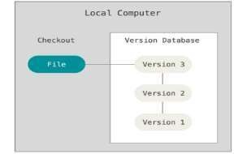
TYPES OF VERSION CONTROL SYSTEMS LOCAL VERSION CONTROL SYSTEMS

Fig . Local Version Control Systems

48

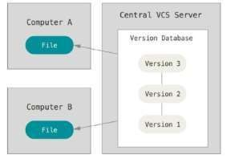
CENTRALIZED VERSION CONTROL SYSTEMS
Fig. Centralized Version Control Systems

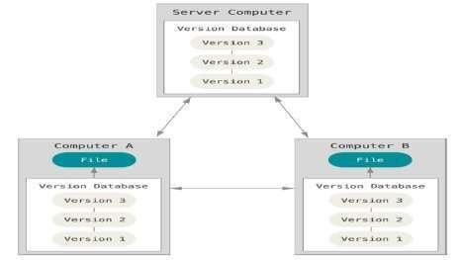
DISTRIBUTED VERSION CONTROL SYSTEMS
Fig. Distributed Version Control Systems

THE THREE STATES
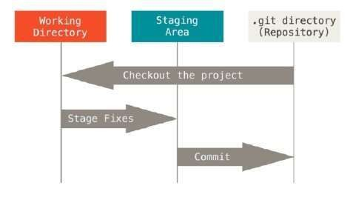

Fig. The Three States

49

SETTING UP A GIT REPOSITORY

Initialize Git
$ git init
This creates a new subdirectory named .git that contains all of your necessary repository files.Git add commands that specify the files for track, followed by a git commit:

Add Files
$ git add .

Commit the Files
$git commit -m "Initial commit“

RECORDING CHANGES TO THE REPOSITORY
Each file in the working directory can be in one of two states: tracked or untracked.
Tracked files are files that were in the last snapshot; they can be unmodified, modified, or staged.
Untracked files are everything else – any files in your working directory that were
not in your last snapshot and are not in your staging area.

Check the Status of Your Files
$git status This shows:
- Modified files.
- Untracked files (new files not yet in Git).
- Staged vs. unstaged changes.

Stage the Changes
To record a change, you must first stage the files (mark them for commit):

Stage a specific file:
$git add filename.ext

Stage all changed files:
$git add .

Commit the Changes

Once staged, create a commit with a message describing the change:

$git commit -m "Describe what you changed here"
50

VIEWING THE COMMIT HISTORY
After the creation of few commits or the repository is cloned with the existing
history and to see what happened, the git log command can be used.

View Full Commit Log
$git log.

View History for a Specific File
$git log filename.ext

View with Diffs (What Changed in Each Commit):
$git log –p

UNDOING THINGS

Undo Changes in a Modified File (Not Yet Staged):
$git checkout -- filename.ext

Unstage a File (You Ran git add, But Not commit)
$git reset HEAD filename.ext

Amend the Last Commit
$git add filename.ext
$git commit –amend

Reset to a Previous Commit (Destructive – Use with Caution)
$git reset --hard <commit-hash>

WORKING WITH REMOTES
Remote repositories are versions of the project that are hosted on the Internet or network somewhere. Collaborating with others involves managing these remote repositories and pushing and pulling data to and from them when it need to share
work.

Add a Remote Repository
$git remote add origin https://github.com/username/repo-name.git

Push Code to Remote
$git push -u origin main

Pull Updates from Remote
$git pull origin main 51

Fetch vs. Pull
$git fetch origin
$git merge origin/main

Change the Remote URL
$git remote set-url origin <new-url>

TAGGING
Tagging is used to know how to list the available tags, how to create new tags, and what the different types of tags are

LISTING YOUR TAGS
Listing the available tags in Git is straightforward. Run git tag:

CREATING TAGS
Git uses two main types of tags:

-Lightweight
-Annotated
A lightweight tag is very much like a branch that doesn’t change, it is just a pointer to a specific commit.
$git tag v1.0

View Existing Tags
$git tag

Delete a Tag
$git tag -d v1.0
Annotated tags are stored as full objects in the Git database.

52

ANNOTATED TAGS
Creating an annotated tag in Git is simple. The easiest way is to specify -a when run
the tag command:

$ git tag -a v1.4 -m "my version 1.4"
$ git tag
v0.1 v1.3 v1.4
The -m specifies a tagging message, which is stored with the tag.
To see the tag data along with the commit that was tagged by using the git show
command:

$ git show v1.4
tag v1.4
Tagger: Ben Straub <ben@straub.cc> Date: Sat May 3 20:19:12 2014 -0700
my version 1.4
commit ca82a6dff817ec66f44342007202690a93763949

LIGHTWEIGHT TAGS
Other way to tag commits is with a lightweight tag. This is basically the commit checksum stored in a file, no other information is kept. To create a lightweight tag, don’t supply the -a, -s, or -m option:

$ git tag v1.4-lw
$ git tag
v0.1
Run git show on the tag, don’t see the extra tag information. The command just
shows the commit:

$ git show v1.4-lw
commit ca82a6dff817ec66f44342007202690a93763949

53

GIT ALIASES
Git doesn’t automatically infer the command if the type it in partially. If it don’t want to type the entire text of each of the Git commands, it can easily set up an alias for
each command using git config. Here are a couple of examples may want to set up:

$ git config --global alias.co checkout
$ git config --global alias.br branch
$ git config --global alias.ci commit
$ git config --global alias.st status
Instead of typing git commit, just need to type git ci. On using Git, it will probably
use other commands frequently as well; don’t hesitate to create new aliases.
This technique can also be very useful in creating commands that the think should exist. For example, to correct the usability problem that encountered with unstaging a file, then can add the own unstage alias to Git:

GIT BRANCHING
Branching means diverging from the main line of development and continue to do
work without messing with that line.
- Isolate development work without affecting the main branch (main/master).
- Experiment safely without breaking production code.
- Enable parallel workflows (multiple developers working on different features simultaneously).
- Simplify bug fixes by creating dedicated branches for issues.

BRANCHES IN A NUTSHELL
Branches are one of Git's most powerful features, allowing you to work on different versions of your code simultaneously without affecting the main codebase.

Default Branch:
Traditionally called master, now commonly main,Contains your production-ready code

Feature Branches:

Isolated workspaces for new features/bug fixes, Created from and merged back into main branch.
54

CREATING A NEW BRANCH AND SWITCHING TO IT AT THE SAME TIME
To create a new branch and want to switch to that new branch at the same time this can be done with git checkout –b <newbranchname>.
Create a new branch and switch to it: git switch -c new-branch. The -c flag stands for create, we can also use the full flag: --create.
Return to previously checked out branch: git switch.

BASIC BRANCHING AND MERGING
Steps for branching and merging with a workflow that might be used in the real world:
- Do some work on a website.
- Create a branch for working on a new user story.
- Do some work in that branch.
To solve a critical issue by hotfix, following steps will be followed:
- Switch to production branch.
- Create a branch to add the hotfix.
- After it is tested, merge the hotfix branch, and push to production.
- Switch back to your original user story and continue working.

BASIC BRANCHING
Consider in a project couple of commits are already done on the master branch.

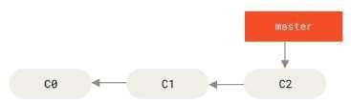

Fig. A simple commit history

55

To work on issue #53 in whatever issue-tracking system company uses, create a new branch and switch to it at the same time using git checkout command with the - b switch:
$ git checkout -b iss53 Switched to a new branch "iss53" This is shorthand for:

$ git branch iss53
$ git checkout iss53

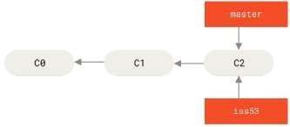
Fig. Creating a new branch pointer

BASIC MERGING
To merge iss53 branch into master branch, check out the branch and then run the git merge command:

$ git checkout master
Switched to branch 'master'

$ git merge iss53
Merge made by the 'recursive' strategy. index.html | 1 + 1 file changed, 1 insertion(+)
Git does a simple three-way merge, using the two snapshots pointed to by the branch tips and the common ancestor of the two.

56

BRANCH MANAGEMENT
To see the last commit on each branch,

$ git branch -v
The useful --merged and --no-merged options can filter this list to branches merged into the current branch. To see which branches are already merged into the Branch run the following command:

$ git branch --merged
iss53
- Master
To see all the branches that contain work not yet merged, run the following command:

$ git branch --no-merged
testing
This shows the other branch. Because it contains work that is not merged in yet, trying to delete it with git branch -d will fail:

$ git branch -d testing
error: The branch 'testing' is not fully merged. To forcefully delete it, run the following:

$ git branch -D testing.
To chat what is not merged into the master branch?

$ git checkout testing
$ git branch --no-merged master
topicA feature

CHANGING A BRANCH NAME
Rename the branch locally with the git branch --move command:

$ git branch --move bad-branch-name corrected-branch-name
This replaces your bad-branch-name with corrected-branch-name, but this change is only locally.

57

BRANCHING WORKFLOWS
Lightweight branching makes common workflow possible, and it can be to incorporated into development cycle.

LONG-RUNNING BRANCHES
Because Git uses a simple three-way merge, merging from one branch into another multiple times over a long period is generally easy to do. Many Git developers have a workflow that embraces this approach, such as having only code that is entirely
stable in their master branch possibly only code that has been or will be released. They have another parallel branch named develop or next that they work from or use to test stability. it is not necessarily always stable, but whenever it gets to a stable state, it can be merged into master.
It’s used to pull in topic branches (short-lived branches, like is s53 branch) when They are ready, to make sure they pass all the tests and don’t introduce bugs.
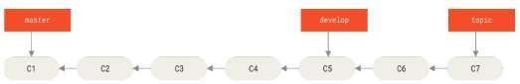
The stable branches are farther down the line in commit history, and the bleeding- edge branches are farther up the history.
Fig. A linear view of progressive-stability branching
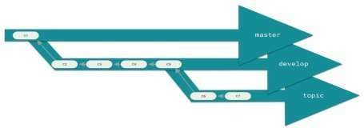

Fig. A “silo” view of progressive-stability branching
Having multiple long-running branches isn’t necessary, but it is often helpful, especially while dealing with very large or complex projects.
Topic Branches

58

- Topic branches, however, are useful in projects of any size. A topic branch is a
short-lived branch used for a single particular feature or related work.
- Consider an example of doing some work (on master), branching off for an issue (iss91), working on it for a bit, branching off the second branch to try another way of
handling the same thing (iss91v2), going back to master branch and working there for a while, and then branching off there to do some work that are not sure is a good idea (dumbidea branch). The commit history will look something like this:
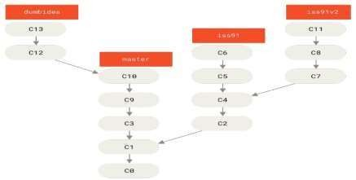
Fig 1.31 Multiple topic branches
If suppose the second solution to the issue is best (iss91v2); and if the dumbidea branch is selected, and need to throw away the original iss91 branch (losing commits
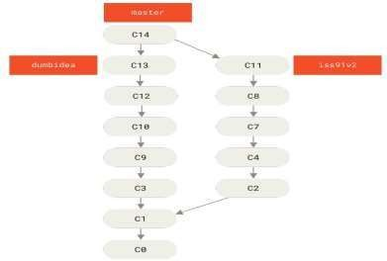
C5 and C6) and merge in the other two, it can be done. The history then looks like this:

Fig 1.32 History after merging dumbidea and iss91v2

59

REMOTE BRANCHES

Remote references are references (pointers) in the remote repositories, including branches, tags, and so on. We can get a full list of remote references explicitly with git ls-remote <remote>
or
git remote show <remote> for remote branches as well as more information.

Remote-tracking branches are references to the state of remote branches.
“origin” is not special. Just like the branch name “master” does not have any special meaning in Git, neither does “origin”. While “master” is the default name for a starting branch to run git init, “origin” is the default name for a remote while running git clone.
Git allows users to use several methods for listing remote branches: git branch -r. Lists all the remote branches.
git branch -r -v. Lists all the remote branches with the latest commit hash and commit message.
git ls-remote. Lists all the references in the remote repository, including the branches. git remote show [remote_name]. Shows information about the specified remote, including the remote branches.
git branch -a. Shows all the local and remote branches.

REBASING
In Git, there are two main ways to integrate changes from one branch into another: the merge and the rebase.

THE BASIC REBASE
In Basic Merging, we diverged the work and made commits on two different branches.

60

REBASE VS. MERGE

Feature | Git Merge | Git Rebase
History | Preserves original commit history, including merge commits, resulting in a non- linear history. | Rewrites commit history by moving commits to a new base, resulting in a linear history without merge commits.
Commit Structure | Creates a new "merge commit" that combines the changes from two branches. | Replays individual commits from one branch onto another, creating new commit hashes for the replayed commits.
Destructive | Non-destructive; does not alter existing commits. | Destructive; rewrites commit history, which can be problematic if the rebased branch has already been pushed and shared.
Conflict Resolution | Conflicts are resolved once in the merge commit. | Conflicts may need to be resolved multiple times as each commit is replayed during the rebase process.
Use Cases | Suitable for integrating completed features into a main branch while maintaining a clear record of branch integration. | Suitable for cleaning up local, in- progress feature branches before sharing, or for creating a cleaner, linear history for a main branch.
Collaboration | Generally preferred for shared branches to avoid rewriting history that others depend on. | Can be used on private branches before pushing to a shared repository, but caution is required when rebasing shared branches.

61

GITHUB
GitHub is the single largest host for Git repositories and is the central point of collaboration for millions of developers and projects. A large percentage of all Git repositories are hosted on GitHub, and many open-source projects use it for Git hosting, issue tracking, code review, and other things.

ACCOUNT SET UP AND CONFIGURATION
- Set up a free user account by visiting https://github.com
- Fill sign up form for github
- Clicking the Octocat logo at the top-left of the screen will navigate to dashboard page.
- Public key can be configured if one wants to have SSH access
- click the “Add an SSH key” button, give key a name, paste the contents of
~/.ssh/id_rsa.pub public-key file into the text area, and click “Add key
- Add Profile details like email address and profile picture and two factor authentication can be used to enhance security.

CONTRIBUTION TO PROJECTS
- FORKING PROJECTS
- When one have to use the existing project in git without push access fork command can be used. Fork command will clone or copy the existing project and further update can be done on cloned project.
- To fork a project, visit the project page and click the “Fork” button at the top- right of the page. After a few seconds, you’ll be taken to your new project page, with your own writeable copy of the code.

GITHUB FLOW
GitHub is designed around a particular collaboration workflow, centered on Pull Requests. This flow works whether you’re collaborating with a tightly-knit team in a single shared repository, or a globally-distributed company or network of strangers contributing to a project through dozens of forks. It is centered on the Topic Branches workflow covered in Git Branching.

62

Here’s how it generally works:
- Fork the project.
- Create a topic branch from master.
- Make some commits to improve the project.
- Push this branch to your GitHub project.
- Open a Pull Request on GitHub.
- Discuss, and optionally continue committing.
- The project owner merges or closes the Pull Request.
- Sync the updated master back to your fork.

CREATING A PULL REQUEST
Tony is looking for code to run on his Arduino programmable microcontroller And has found a great program file on GitHub at https://github.com/schacon/blink.
First, we click the 'Fork' button as mentioned earlier to get our own copy of the project. Our user name here is “tonychacon” so our copy of this project is at
https://github.com/tonychacon/blink and that’s where we can edit it. We will clone it locally, create a topic branch, make the code change and finally push that change back up to GitHub.

$ git clone https://github.com/tonychacon/blink ①
Cloning into 'blink'...

$ cd blink
$ git checkout -b slow-blink ②
Switched to a new branch 'slow-blink'

$ git diff --word-diff ④
diff --git a/blink.ino b/blink.ino index 15b9911..a6cc5a5 100644
--- a/blink.ino
+++ b/blink.ino

63

$ git commit -a -m 'Change delay to 3 seconds' ⑤
$ git push origin slow-blink ⑥
    - [new branch] slow-blink -> slow-blink
① Clone our fork of the project locally.
② Create a descriptive topic branch.
③ Make our change to the code.
④ Check that the change is good.
⑤ Commit our change to the topic branch.
⑥ Push our new topic branch back up to our GitHub fork.
we can alternatively go to the “Branches” page at
https://github.com/<user>/<project>/branches to locate your branch and open
a new Pull Request from there.

MAINTAINING A PROJECT
Now that we’re comfortable contributing to a project, let’s look at the other
side: creating,maintaining and administering your own project.

CREATING A NEW REPOSITORY
Let’s create a new repository to share our project code with. Start by clicking the
“New repository” button on the right-hand side of the dashboard, or from the + button in the top toolbar next to username as seen in The “New repository” dropdown.

ADDING COLLABORATORS
If you’re working with other people who you want to give commit access to, you need to add them as “collaborators”. If Ben, Jeff, and Louise all sign up for accounts on GitHub, and you want to give them push access to your repository,
you can add them to your project. Doing so will give them “push” access, which
means they have both read and write access to the project and Git repository.
Click the “Settings” link at the bottom of the right-hand sidebar.
Then select “Collaborators” from the menu on the left-hand side. Then, just
type a
username into the box, and click “Add collaborator.” You can repeat this as many
times as you like to grant access to everyone you like. If you need to revoke access,
just click the “X” on the right-hand side of their row.

64

MANAGING PULL REQUESTS
Now that you have a project with some code in it and maybe even a few collaborators who also have push access, let’s go over what to do when you get a
Pull Request yourself.
Pull Requests can either come from a branch in a fork of your repository or they can come from another branch in the same repository. The only difference is that the ones in a fork are often from people where you can’t push to their branch and they
can’t push to yours, whereas with internal Pull Requests generally both parties can access the branch.

EMAIL NOTIFICATIONS
There are a few things to notice about this email. It will give you a small diffstat — a list of files that have changed in the Pull Request and by how much. It gives you a
link to the Pull Request on GitHub. It also gives you a few URLs that you can use from the command line.
If you notice the line that says git pull <url> patch-1, this is a simple way to merge in a remote branch without having to add a remote. We went over this quickly in Checking Out Remote Branches.
$ curl https://github.com/tonychacon/fade/pull/1.patch | git am

COLLABORATING ON THE PULL REQUEST
As we covered in The GitHub Flow, you can now have a conversation with the person who opened the Pull Request. You can comment on specific lines of code, comment on whole commits or comment on the entire Pull Request itself, using GitHub Flavored Markdown everywhere. Every time someone else comments on the Pull Request you will continue to get email notifications so you know there is activity happening.

MENTIONS AND NOTIFICATIONS
GitHub also has a pretty nice notifications system built in that can come in handy
when you have questions or need feedback from specific individuals or teams.
In any comment you can start typing a @ character and it will begin to autocomplete with the names and usernames of people who are collaborators or contributors in
the project.

65

CONTRIBUTING
The other special file that GitHub recognizes is the CONTRIBUTING file. If you have a file named CONTRIBUTING with any file extension, GitHub will show Opening a Pull Request when a CONTRIBUTING file exists when anyone starts opening a Pull Request.
The idea here is that you can specify specific things you want or don’t want in a Pull Request sent to your project. This way people may actually read the guidelines before opening the Pull Request.

Project Administration
Generally there are not a lot of administrative things you can do with a single project, but there are a couple of items that might be of interest.

CHANGING THE DEFAULT BRANCH
If you are using a branch other than “master” as your default branch that you want people to open Pull Requests on or see by default, you can change that in your repository’s settings page under the “Options” tab.
Simply change the default branch in the dropdown and that will be the default for
all major operations from then on, including which branch is checked out by default
when someone clones the repository.

TRANSFERRING A PROJECT
If you would like to transfer a project to another user or an organization in GitHub, there is a “Transfer ownership” option at the bottom of the same “Options” tab of
your repository settings page that allows you to do this.
This is helpful if you are abandoning a project and someone wants to take it over, or if your project is getting bigger and want to move it into an organization.

SCRIPTING GITHUB
So now we’ve covered all of the major features and workflows of GitHub, but any large group or project will have customizations they may want to make or external
services they may want to integrate.

SERVICES AND HOOKS
The Hooks and Services section of GitHub repository administration is the easiest way to have GitHub interact with external systems.

66

SERVICES
First we’ll take a look at Services. Both the Hooks and Services integrations can be found in the Settings section of your repository, where we previously looked at adding Collaborators and changing the default branch of your project. Under the
“Webhooks and Services” tab you will see something like Services and Hooks
configuration section.
In this case, if we hit the “Add service” button, the email address we specified will get an email every time someone pushes to the repository. Services can listen for lots of different types of events, but most only listen for push events and then do something with that data.

HOOKS
If you need something more specific or you want to integrate with a service or site that is not included in this list, you can instead use the more generic hooks system. GitHub repository hooks are pretty simple. You specify a URL and GitHub will post an
HTTP payload to that URL on any event you want.
Generally the way this works is you can setup a small web service to listen for a
GitHub hook payload and then do something with the data when it is received.
To enable a hook, you click the “Add webhook” button in Services and Hooks configuration section. This will bring you to a page that looks like Web hook configuration.
The configuration for a web hook is pretty simple. In most cases you simply enter a URL and a secret key and hit “Add webhook”. There are a few options for which events you want GitHub to send you a payload for — the default is to only get a payload for the push event, when someone pushes new code to any branch of your repository.
For more information on how to write webhooks and all the different event types you can listen for, go to the GitHub Developer documentation at https://developer.github.com/webhooks/.

67

10. ASSIGNMENT : UNIT – I

(CO1 CO2, K2 K3)

Infosys Springboard Course:

Software Engineering and Agile Software Development

Link to access the course:

https://infyspringboard.onwingspan.com/web/en/ app/toc/lex_auth_013382690411003904735_sh ared/overview

68

PART A Q&A UNIT - I

S N O | QUESTION AND ANSWERS | CO1, CO2 | k2, k3
1 | List the goals of software engineering?  Satisfy user requirements , High reliability , Low maintenance  cost , Delivery on time , Low production cost , High performance , Ease of reuse. | CO1 | K2
2 | What is the difference between verification and validation?  Verification refers to the set of activities that ensure that  Software correctly implements a specific function.  Verification: "Are we building the product right?"  Validation refers to a different set of activities that ensure that the software that has been built is traceable to customer requirements. Validation: "Are we building the right product?“ | CO1 | K2
3 | What are the two types of software products?  1. Generic products: these are stand-alone systems that are produced by a development Organization and sold in the open market to any customer who wants to buy it. 2.Customized products: these are systems that are commissioned by a specific customer and developed specially by some contractor to meet a special need. | CO1 | K2

69

SN O | QUESTION AND ANSWERS | CO1, CO3 | k2,k 3
4 | What is the advantage of adhering to life cycle models for software?  It helps to produce good quality software products without time and cost over runs. It encourages the development of software in a systematic & disciplined manner. | CO1 | K2
5 | What is software process? List its activities.  Software process is defined as the structured set of activities that are required to develop the software system.  Activities – Specification, design & implementation, validation & evolution. | CO1 | K2
6 | What does Verification represent?  Verification represents the set of activities that are carried out to confirm that the software correctly implements the specific functionality. | CO1 | K2
7 | What does Validation represent?  Validation represents the set of activities that ensure that the software that has been built is satisfying the customer requirements. | CO1 | K2
8. | What is meant by Software engineering paradigm?  The development strategy that encompasses the process, methods and tools and generic phases is often referred to as a process model or software engineering paradigm. | CO1 | K2

70

SN  O | QUESTION AND ANSWERS | CO1,  CO3 | k2,k3
9 | Define agility and agile team.  Agility-Effective (rapid and adaptive) response to change (team members, new technology, requirements)  Effective communication in structure and attitudes among all team members, technological and business people, software engineers and managers。  Drawing the customer into the team. Eliminate “us and them” attitude.  Planning in an uncertain world has its limits and plan must be  flexible.  Organizing a team so that it is in control of the work performed  The development guidelines stress delivery over analysis and design although these activates are not discouraged, and active and continuous Communication between developers and customers  Eliminate all but the most essential work products and keep them lean.  Emphasize an incremental delivery strategy as opposed to intermediate products that gets working software to the customer as rapidly as feasible. | CO1 | K2
10 | Write any two characteristics of software as a product.  - Software is developed or engineered, it is not manufactured in the classical sense  - Software doesn't "wear out."  - Although the industry is moving toward component-based assembly, most software continues to be custom built. | CO1 | K2
11 | Write the IEEE definition of software engineering. According to IEEE's definition software engineering can be defined as the application of a systematic, disciplined, quantifiable approach to the development, operation, and maintenance of software, and the study of these approaches; that is, the application of engineering to software. | CO1 | K2
12 | List two deficiencies in waterfall model . Which process model do you suggest to overcome each deficiency.  Once an application is in the testing stage, it is very difficult to go back and change something that was not well-thought out in the concept stage.  No working software is produced until late during the life cycle. | CO1 | K2

71

SN  O | QUESTION AND ANSWERS | CO1,  CO3 | k2,k  3
13 | What is Agile?  The word ‘agile’ means −  Able to move your body quickly and easily. Able to think quickly  and clearly.  In business, ‘agile’ is used for describing ways of planning and doing work wherein it is understood that making changes as needed is an important part of the job. Business ‘agility’ means that a company is always in a position to take account of the market changes.  In software development, the term ‘agile’ is adapted to mean ‘the ability to respond to changes − changes from Requirements, Technology and People.’ | CO1 | K2
14 | What is Agile Manifesto?  The Agile Manifesto states that −We are uncovering better ways of developing software by doing it and helping others do it.  Through this work, we have come to value − Individuals and interactions over processes and tools. Working software over comprehensive documentation. Customer collaboration over contract negotiation.  Responding to change over following a plan.  That is, while there is value in the items on the right, we value the items on the left more | CO1 | K2
15 | What are the Characteristics of Agility?  Agility in Agile Software Development focuses on the culture of the whole team with multi-discipline,cross-functional teams that are empowered and self organizing.  It fosters shared responsibility and accountability.  Facilitates effective communication and continuous collaboration. The whole-team approach avoids delays and wait times. Frequent and continuous deliveries ensure quick feedback that in in turn  enable the team align to the requirements.  Collaboration facilitates combining different perspectives timely in implementation, defect fixes and accommodating changes | CO1 | K2

72

SN O | QUESTION AND ANSWERS | CO1, CO2 | k2,k3
16 | What are the principles of agile methods?  Customer involvement Customers should be closely involved throughout the development process. Their role is provide and prioritize new system requirements and to  evaluate the iterations of the System.  Incremental delivery  The software is developed in increments with the customer specifying the requirements to be included in each increment. People not process  The skills of the development team should be recognized and  exploited. Team members should be left to develop their own  ways of working without prescriptive processes.  Embrace change  Expect the system requirements to change and so design the system to accommodate these changes.  Maintain simplicity  Focus on simplicity in both the software being developed and in the development process. Wherever possible, actively work to eliminate complexity from the system. | CO1 | K2
17 | What are the Problems with agile methods?  It can be difficult to keep the interest of customers who are involved in the process.  Team members may be unsuited to the intense involvement  that characterizes agile methods.  Prioritizing changes can be difficult where there are multiple stakeholders.  Maintaining simplicity requires extra work.  Contracts may be a problem as with other approaches to  iterative development. | CO1 | K2

73

SNO | QUESTION AND ANSWERS | CO | k2,k3
18 | What is Extreme Programming?  XP is a lightweight, efficient, low-risk, flexible, predictable, scientific, and fun way to develop a software. Extreme Programming (XP) was conceived and developed to address the specific needs of software development by small teams in the face of vague and changing requirements.  Extreme Programming is one of the Agile software development methodologies. It provides values and principles to guide the team behavior. The team is expected to self- organize.  Extreme Programming provides specific core practices where each practice is simple and self-complete. Combination of practices produces more complex and emergent behavior. | CO1 | K2
19 | HOW Embrace Change happens in Extreme programming?  A key assumption of Extreme Programming is that the cost of  changing a program can be held mostly constant over time.  This can be achieved with −  Emphasis on continuous feedback from the customer Short iterations  Design and redesign  Coding and testing frequently  Eliminating defects early, thus reducing costs  Keeping the customer involved throughout the development  Delivering working product to the customer. | CO1 | K2
20 | How Extreme Programming used in a Nutshell?  Extreme Programming involves −  Writing unit tests before programming and keeping all of the tests running at all times. The unit tests are automated and eliminate defects early, thus reducing the costs.  Starting with a simple design just enough to code the features at hand and redesigning when required.  Programming in pairs (called pair programming), with two programmers at one screen, taking turns to use the keyboard. While one of them is at the keyboard, the other constantly reviews and provides inputs.  Integrating and testing the whole system several times a day. | CO1 | K2

74

SN O | QUESTION AND ANSWERS | CO1, CO2 | k2,k3
21 | Why is it called “Extreme?  Extreme Programming takes the effective principles and practices to extreme levels.  Code reviews are effective as the code is reviewed all the time.  Testing is effective as there is continuous regression and testing.  Design is effective as everybody needs to do refactoring daily.  Integration testing is important as integrate and test several times a day.  Short iterations are effective as the planning game for  release planning and iteration planning. | CO1 | K2
22 | What are the Extreme Programming Advantages? Extreme Programming solves the following problems often faced in the software development projects −  Slipped schedules − and achievable development cycles  ensure timely deliveries.  Cancelled projects − Focus on continuous customer involvement ensures transparency with the customer and immediate resolution of any issues.  Costs incurred in changes − Extensive and ongoing testing makes sure the changes do not break the existing functionality. A running working system always ensures sufficient time for accommodating changes such that the current operations are not affected.  Production and post-delivery defects: Emphasis is on − the  unit. | CO1 | K2
23 | What is Scrum?  The Scrum approach is a general agile method but its focus is on managing iterative development rather than specific agile practices. There are three phases in Scrum: 1.The initial phase is an outline planning phase where you establish the general objectives for the project and design the software architecture.  2.This is followed by a series of sprint cycles, where each  cycle develops an increment of the system. | CO1 | K2

75

SN O | QUESTION AND ANSWERS | CO1, CO2 | K3, K6
 | 3. The project closure phase wraps up the project, completes required documentation such as system help frames and user manuals and assesses the lessons learned from the project.
24 | What are the Advantages of scrum?  The product is broken down into a set of manageable and  understandable chunks.  Unstable requirements do not hold up progress.  The whole team has visibility of everything and consequently team communication is improved.  Customers see on-time delivery of increments and gain feedback  on how the product works.  Trust between customers and developers is established and a positive culture is created in which everyone expects the project to  succeed. | CO1 | K2
25 | Mention the Two perspectives on scaling of agile methods?  - Scaling up  - Scaling out | CO1 | K2
26 | What is Scaling up?  Using agile methods for developing large software systems that cannot be developed by a small team. For large systems development, it is not possible to focus only on the code of the system; you need to do more up- front design and system documentation. Cross-team communication mechanisms have to be designed and used, which should involve regular phone and video conferences between team members and frequent, short electronic meetings where teams update each other on progress. Continuous integration, where the whole system is built every time any developer checks in a change, is practically impossible; however, it is essential to maintain frequent system builds and regular releases of the system. | CO1 | K2

76

SN O | QUESTION AND ANSWERS | CO1, CO2 | k2,k3
27 | What is Scaling out?  How agile methods can be introduced across a large organization with many years of software development experience. Project managers who do not have experience of agile methods may be reluctant to accept the risk of a new approach. Large organizations often have quality procedures and standards that all projects are expected to follow and, because of their bureaucratic nature, these are likely to be incompatible with agile methods. Agile methods seem to work best when team members have a relatively high skill level.  However, within large organizations, there are likely to be a wide range of skills and abilities. | CO1 | K2
28 | What is agile development?  Specification, design, implementation and testing are inter- leaved and the outputs from the development process are decided through a process of negotiation during the software  development process. Projects include elements of plan- driven and agile processes. Deciding on the balance depends on many technical, human, and organizational issues. | CO1 | K2
29 | What is Scrum master?  The role of the Scrum Master is to protect the development team from external distractions. At the end of the sprint the work done is reviewed and presented to  stakeholders (including the product owner). | CO1 | K2
30 | List the types of Version Control System.  Local Version Control System Centralized Version Control  System Distributed Version Control System | CO2 | K3
31 | Write a command that initialize the repository in the existing directory?  For Starting the existing project, run the command from the project directory  $ git init | CO2 | K3

77

SN O | QUESTION AND ANSWERS | CO1, CO2 | k2,k 3
32 | How to get a copy of an existing Git repository?  The command need is git clone. clone a repository with git clone [url].  For example, to clone the Git linkable library called libgit2, use the format given below:  $ git clone https://github.com/libgit2/libgit2 | CO2 | K3
33 | Define the two states of the file in the working directory.  Tracked files are files that were in the last snapshot; they  can be unmodified, modified, or staged.  Untracked files are everything else – any files in the working directory that were not in last snapshot and are not in staging area. | CO2 | K3
34 | Define and Mention the two types of tags in tagging. Git uses two main types of tags: - Lightweight, Annotated A lightweight tag is very much like a branch that doesn’t change, it is just a pointer to a specific commit.  Annotated tags are stored as full objects in the Git database. | CO2 | K3
35 | Write the command for adding the remote repositories.  To add a new remote Git repository as a shortname that can reference easily, run git remote add <shortname> <url>:  $ git remote  origin  $ git remote add pb https://github.com/paulboone/ticgit  $ git remote -v  origin https://github.com/schacon/ticgit (fetch) origin https://github.com/schacon/ticgit (push) pb https://github.com/paulboone/ticgit (fetch) pb https://github.com/paulboone/ticgit (push) | CO2 | K3
36 | What is the command used to unmodifying the modified file?  Use git checkout option, for unmodifying the changes made.  $ git checkout -- CONTRIBUTING.md | CO2 | K3
37 | How to install github in linux?  By using the command, the github can be installed.  $ sudo yum install git-all (or) $ sudo apt-get install git-all | CO2 | K3

78

SN O | QUESTION AND ANSWERS | CO1, CO2 | k2,k 3
38 | What is a branch in Git?  A branch in Git is simply a lightweight movable pointer to one of these commits.  The default branch name in Git is master. When making  commits, a master branch will be created that points to the  last commit made.  When commit is done, the master branch pointer moves forward automatically.  The “master” branch in Git is not a special branch. It is  exactly like any other branch. | CO2 | K3
39 | How to resolve a conflict in Git?  The following steps will resolve conflict in Git- Identify the files that have caused the conflict.  Make the necessary changes in the files so that conflict does not arise again.  Add these files by the command git add.  Finally to commit the changed file using the command git  commit. | CO2 | K3
40 | What is the difference between git pull and git fetch? Git pull command pulls new changes or commits from a particular branch from your central repository and updates your target branch in your local repository.  Git fetch is also used for the same purpose but it works in a slightly different way. When you perform a git fetch, it pulls all new commits from the desired branch and stores it in a new branch in your local repository. If you want to reflect these changes in your target branch, git fetch must be followed with a git merge. Your target branch will only be updated after merging the target branch and fetched  branch. Just to make it easy for you, remember the equation below:  Git pull = git fetch + git merge | CO2 | K3
41 | What work is restored when the deleted branch is recovered?  The files which were stashed and saved in the stash index list will be recovered back. Any untracked files will be lost. Also, it is a good idea to always stage and commit your work or stash them. | CO2 | K3
42 | What is the function of ‘git stash apply’?  If you want to continue working where you had left your work then ‘git stash apply‘ command is used to bring back the saved changes onto your current working directory. | CO2 | K3
79

SN  O | QUESTION AND ANSWERS | CO1,  CO2 | k2,k  3
43 | What is the difference between the ‘git diff ’and ‘git status’?  ‘git diff ’ depicts the changes between commits, commit and working tree, etc. whereas ‘git status’ shows you the difference between the working directory and the index, it is helpful in understanding a git more comprehensively. ‘git diff’ is similar to ‘git status’, the only difference is that it shows the differences between various commits and also between the working directory and index. | CO2 | K3
44 | What is the difference between ‘git remote’ and ‘git clone’?  ‘git remote add’ creates an entry in your git config that specifies a name for a particular URL whereas ‘git clone’ creates a new git repository by copying an existing one located at the URL. | CO2 | K3
45 | How will you know in Git if a branch has already been merged into master?  The answer is pretty direct.  To know if a branch has been merged into master or not you  can use the below commands:  git branch --merged – It lists the branches that have been merged into the current branch.  git branch --no-merged – It lists the branches that have not been merged. | CO2 | K3
46 | Define github.  GitHub is the single largest host for Git repositories, and is the central point of collaboration for millions of developers and projects. A large percentage of all Git repositories are hosted on GitHub,and many open-source projects use it for Git hosting, issue tracking, code review, and other things. | CO2 | K3
47 | Elaborate Two Factor Authentication.  Two-factor Authentication or “2FA”. Two_x0002_factor Authentication is an authentication mechanism that is becoming more and more popular recently to mitigate the risk of your account being compromised if your password is stolen somehow. Turning it on will make GitHub ask you for two different methods of authentication, so  that if one of them is compromised, an attacker will not be able to access your account. | CO2 | K3

80

SN O | QUESTION AND ANSWERS | CO1, CO2 | k2,k 3
48 | Define Scripting GitHub.  covered all of the major features and workflows of GitHub, but any large group or project will have customizations they may want to make or external services they may want to integrate. Luckily for us, GitHub is really quite hackable in many ways. | CO2 | K3
49 | Define Pull Requests on Pull Requests.  Not only can you open Pull Requests that target the main or master branch, you can actually open a Pull Request targeting any branch in the network. In fact, you can even target another Pull Request. | CO2 | K3
50 | Define Creating a New Repository.  create a new repository to share our project code with. Start by clicking the “New repository”button on the right-hand side of the dashboard, or from the + button in the top toolbar next to your  username as seen in The “New repository” dropdown. | CO2 | K3

81

PART B QUESTIONS : UNIT – I

(CO1,CO2 – K2,K3)

- Discuss the various life cycle models in software development?
- List the principles of Agile software development?
- Define XP values and write in detail about Extreme Programming?
- What is the difference between XP and industrial XP? Discuss Industrial Extreme Programming.
- Explain adaptive software development and Scrum.
- Explain Dynamic systems development method and Crystal.
- Explain feature drive development and lean software development.
- Explain agile modeling and agile unified process.
- Describe in detail about the version control system and its types with diagram.
- Write the procedure for installing github in various platform.
- Explain about the need of recording changes in the repository.
- Elaborate the procedure for viewing the commit history.
- Discuss the different ways of undoing things.
- Explain in detail about the Git Aliases.
- Produce what is tagging and its types in detail.
- Write the procedure for accessing and working remote repositories.
- Explain how to contribute to a project through forking.
- Briefly explain how to maintaining a project using GitHub .
- Explain in detail about Git Branching and Management.
- Discuss the branching workflows in detail.
- Write in detail about Remote Branches.
- What is Rebasing? Discuss in detail.

82

PART C (CO1,CO2 – K2,K3)

Case Study - Mentcare: A mental health support system
The system is designed for use in clinics attended by patients suffering from mental health problems and records details of their consultations and conditions. It is separate from a more general patient records system as more detailed information has to be maintained and the system has to be
set up to generate letters and reports of different types.

Case Study iLearn: A digital learning environment
The iLearn system is a digital learning environment used to support learning in schools with students from age 4 to 18. It is intended to replace an existing system (Glow) that was specially built for the purpose and which includes its own applications for e-mail, etc

Case Study - A wilderness weather station
This case study is based on the software for a wilderness weather station that collects weather information in remote areas that do not have local infrastructure (power, communications, roads, etc.). These weather stations are part of a national weather information system that is intended to capture and analyse detailed weather information

Case Study A personal insulin pump
This case study discusses the control software for a personal insulin pump, which is used by diabetics to mimic the function of the pancreas and hence control the level of glucose (sugar) in their blood.

Explain about the following:
Set up and Configure the Project in GitHub. Scripting in GitHub.

83

SUPPORTIVE ONLINE CERTIFICATION COURSES

UNIT I

COURSERA
https://www.coursera.org/professional-certificates/devops-and- software-engineering
https://www.coursera.org/learn/introduction-to-software-engineering https://www.coursera.org/learn/introduction-git-github https://www.coursera.org/learn/getting-started-with-git-and-github

UDEMY
https://www.udemy.com/course/complete-professional-scrum- master-training-exam-simulator/?src=sac&kw=AGILE+S

UDEMY
https://www.udemy.com/topic/Software-Engineering https://www.udemy.com/course/github-ultimate/

NPTEL
https://nptel.ac.in/courses/106105182

84

- REAL TIME APPLICATIONS : UNIT – I

Software Requirements Specification (SRS) – Customer
Relationship Management

Purpose

The purpose of the CRM project is to create a web-based platform for businesses to manage customer data, track interactions, monitor sales, and improve customer satisfaction. It will allow businesses to store customer information, log communications, track leads, and generate reports.

Scope
The CRM system will:

  - Provide a simple HTML-based user interface for data entry and retrieval.
  - Store customer details such as name, contact, email, purchase history.
  - Enable sales teams to add, edit, and delete customer records.
  - Allow managers to track leads, assign tasks, and review performance.
  - Include basic analytics features like sales reports.
  - Serve as a centralized communication hub between the business and its customers.

Functional Requirements

These are the features the system must perform:
- Customer Management
  - Add new customers.
  - View customer profiles.
  - Update customer information.
  - Delete customer records.

85

- Sales & Leads Tracking
  - Create and manage sales leads.
  - Track the sales pipeline stages.
  - Assign leads to sales representatives.
- Communication Tracking
  - Record calls, emails, and meetings with customers.
  - View interaction history.
- Reporting
  - Generate sales performance reports.
  - View customer purchase history.
- User Roles
  - Admin (full control)
  - Sales Staff (limited features)

Non-Functional Requirements
These describe how the system should perform:
  - Performance – The system should load within 3 seconds for any page.
  - Usability – The interface must be simple and user-friendly for non-technical staff.
  - Security – Data should be password-protected and encrypted.
  - Scalability – The system should handle increasing customer records without
slowing down.
  - Reliability – The system should have a 99% uptime.
- Use case Diagram

86

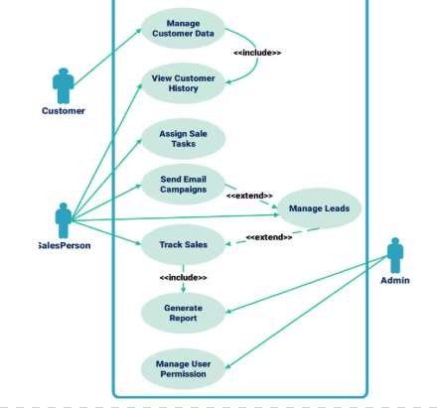

Fig Use case Diagram for CRM

87

CONTENT BEYOND SYLLABUS : UNIT – I

. ADVANCED PULL REQUESTS - GitHub PULL REQUESTS AS PATCHES
It’s important to understand that many projects don’t really think of Pull requests as
queues of perfect patches that should apply cleanly in order, as most mailing list- based projects think of patch series contributions.
Most GitHub projects think about Pull Request branches as iterative conversations around a proposed change, culminating in a unified diff that is applied by Merging.Pushing the “Merge”button on the site purposefully creates a merge commit that references the Pull Request so that it’s easy to go back and research the original conversation if necessary.

KEEPING UP WITH UPSTREAM
If your Pull Request becomes out of date or otherwise doesn’t merge cleanly,
you will want to fix it so the maintainer can easily merge it. GitHub will test this for you and let you know at the bottom of every Pull Request if the merge is trivial or not.

QUOTING
If you are responding to a small part of a long comment, you can selectively quote out of the other comment by preceding the lines with the > character.
In fact, this is so common and so useful that there is a keyboard shortcut for it.
If you highlight text in a comment that you want to directly reply to and hit the r key,
it will quote that text in the comment box for you. The quotes look something like this:
Whether 'tis Nobler in the mind to suffer The Slings and Arrows of outrageous Fortune, How big are these slings and in particular, these arrows? Once rendered, the comment will look like Rendered quoting example.

88

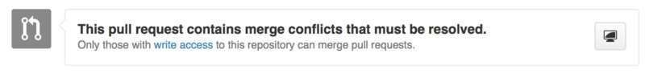
Fig. Pull request does not merge cleanly

$ git remote add upstream https://github.com/schacon/blink ①
$ git fetch upstream ②
$ git merge upstream/master ③
$ vim blink.ino ④
$ git push origin slow-blink ⑤
Counting objects: 6, done.
Delta compression using up to 8 threads.
Compressing objects: 100% (6/6), done.
Writing objects: 100% (6/6), 682 bytes | 0 bytes/s, done. Total 6
(delta 2), reused 0 (delta 0)

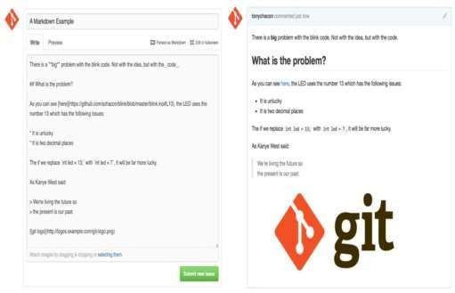
Fig. An example of Github Flavored Markdown as written and as rendered

89

Emoji
Finally, you can also use emoji in your comments. This is actually used quite extensively in comments you see on many GitHub Issues and Pull Requests. There is even an emoji helper in GitHub.
If you are typing a comment and you start with a : character, an autocompleter will help you find what you’re looking for.

Emojis take the form of :<name>: anywhere in hecomment. For instance,
you could write something like this:
I :eyes: that :bug: and I :cold_sweat:.
:trophy: for :microscope: it.
:+1: and :sparkles: on this :ship:, it's :fire::poop:!
:clap::tada::panda_face:

Images

This isn’t technically GitHub Flavored Markdown, but it is incredibly useful. In addition to adding Markdown image links to comments, which can be difficult to find and embed URLs for, GitHub allows you to drag and drop images into text areas to embed them.
If you look at Drag and drop images to upload them and auto-embed them, you can see a small “Parsed as Markdown” hint above the text area. Clicking on that will give you a full cheat sheet of everything you can do with Markdown on GitHub.

$ git checkout master ①
$ git pull https://github.com/progit/progit2.git ②
$ git push origin master ③ ① If you were on another branch, return to master. ② Fetch changes from https://github.com/progit/progit2.git and merge them into master. ③ Push your master branch to origin.

90

ASSESSMENT SCHEDULE

Tentative schedule for the Assessment During 2025-2026 Odd semester

S.NO | Name of the  Assessment | Start Date | End Date | Portion
1 | Unit Test 1 | - | - | UNIT 1
2 | IAT 1 | 14.10.2025 | 18.10.2025 | UNIT 1 & 2
3 | Unit Test 2 | - | - | UNIT 3
4 | IAT 2 | 21.11.2025 | 26.11.2025 | UNIT 3 & 4
5 | Revision 1 | - | - | UNIT 5, 1 & 2
6 | Revision 2 | - | - | UNIT 3 & 4
7 | Model | 11.12.2025 | 19.12.2025 | ALL 5 UNITS

75
91

PRESCRIBED TEXT BOOKS & REFERENCE BOOKS

TEXT BOOKS
  - Roger S. Pressman, “Software Engineering: A Practitioner‘s Approach”, McGraw Hill International Edition, Nineth Edition, 2020.
  - Scott Chacon, Ben Straub, “Pro GIT”, Apress Publisher, 3rd Edition, 2014.
  - Deitel and Deitel and Nieto, “Internet and World Wide Web - How to Program”, Pearson, 5th Edition, 2018.

REFERENCE BOOKS
1 Roman Pichler, “Agile Product Management with Scrum Creating Products that Customers Love”, Pearson Education, 1 st Edition, 2010.
- Jeffrey C and Jackson, “Web Technologies A Computer Science Perspective”,
Pearson Education, 2011.
- Stephen Wynkoop and John Burke, “Running a Perfect Website”, QUE, 2nd Edition, 1999.
- Chris Bates, “Web Programming – Building Intranet Applications”, 3rd Edition,
Wiley Publications, 2009.
- Gopalan N.P. and Akilandeswari J., “Web Technology”, Second Edition, Prentice Hall of India, 2014.
- https://infyspringboard.onwingspan.com/web/en/app/toc/ lex_auth_013382690411003904735_shared/overview 7.https://infyspringboard.onwingspan.com/web/en/app/ toc/lex_auth_0130944214274703362099_shared/overview

92

MINI PROJECT SUGGESTION

SRS Document Preparation and implementation.
Topics suggested:

- Scholarship Management System for students.
- Gram Panchayat Website.
- Blood Donation Website.
- A Food Wastage Management Website.
- Organ Donator and Finder Website.
- Subject Allocation for college Faculty.
- Seminar Hall Booking Website.
- College Admission Management.
- Agri shop: Formers Online Selling.
- Online Complaint Registration and Management System: Street Light, Water
Pipe Leakage, Rain Water Drainage, Road Problem, etc.

93

Thank you

Disclaimer:

This document is confidential and intended solely for the educational purpose of RMK Group of Educational Institutions. If you have received this document through email in error, please notify the system manager. This document contains proprietary information and is intended only to the respective group / learning community as intended. If you are not the addressee you should not disseminate, distribute or copy through e-mail. Please notify the sender immediately by e-mail if you have received this document by mistake and delete this document from your system. If you are not the intended recipient you are notified that disclosing, copying, distributing or taking any action in reliance on the contents of this information is strictly prohibited.

94

